高原地基督教生命堂
主日聯合崇拜
Christian Evangelical Mission Church
in Highland Park
二零一八年五月二十七日下午一時半
May . 27, 2018, 1:30 PM
司會(中)  Chairman: | 謝 徐 穎姊妹  Mrs. Ying Shieh
講員  Speaker: | 盧 義 思博士  Dr. Luis Ruiz
翻譯  Translator: | 彭 李 蓉姊妹  Mrs. Dolly Peng
司琴  Pianist: | 李 澤 岳弟兄  Mr. Morgen Li
司琴  Pianist: | 王馮韺韺姊妹  Mrs. Ying Ying Wang
司獻  Usher: | 凌 偉 歡弟兄  Mr. Michael Ling
司獻  Usher: | 王 正 茂弟兄  Mr. James Wang
清潔  Clean Up: | 王 培 仁弟兄  Mr. Pei Ren Wang
清潔  Clean Up: | 曾戴秀萍姊妹  Ms. Vivian Ng

1 | 序 樂  Prelude |  |  |  |  |  |  | 司琴  Pianist
2 | 宣 召  Call to  Worship | 詩篇Psalm  95:6-7. |  |  |  |  |  |  |  |  |  |  |  |  | 司會  Chairman
3 | 頌讚詩  Hymn of  Praise |  |  | #183 |  |  |  |  |  | 眾立  Cong. Stand
4 | 祈 禱  Prayer |  |  |  |  |  |  |  | 司會  Chairman
5 | 讀 經  Scripture  Reading |  | 詩篇141篇  Psalm 141 |  |  |  |  |  |  |  |  |  |  | 司會  Chairman
6 | 唱 詩  Hymn |  |  |  | #101 |  |  |  |  |  | 眾立  Cong. Stand
7 | 報 告  Announcement |  |  |  |  |  |  |  |  |  |  |  |  | 司會  Chairman
8 | 特別節目  Special Number |  |  |  |  |  |  |  | Dr. Ruiz’s  Family
9 | 證 道  Sermon |  |  |  |  | 盧義思博士  Dr. Ruiz
 | 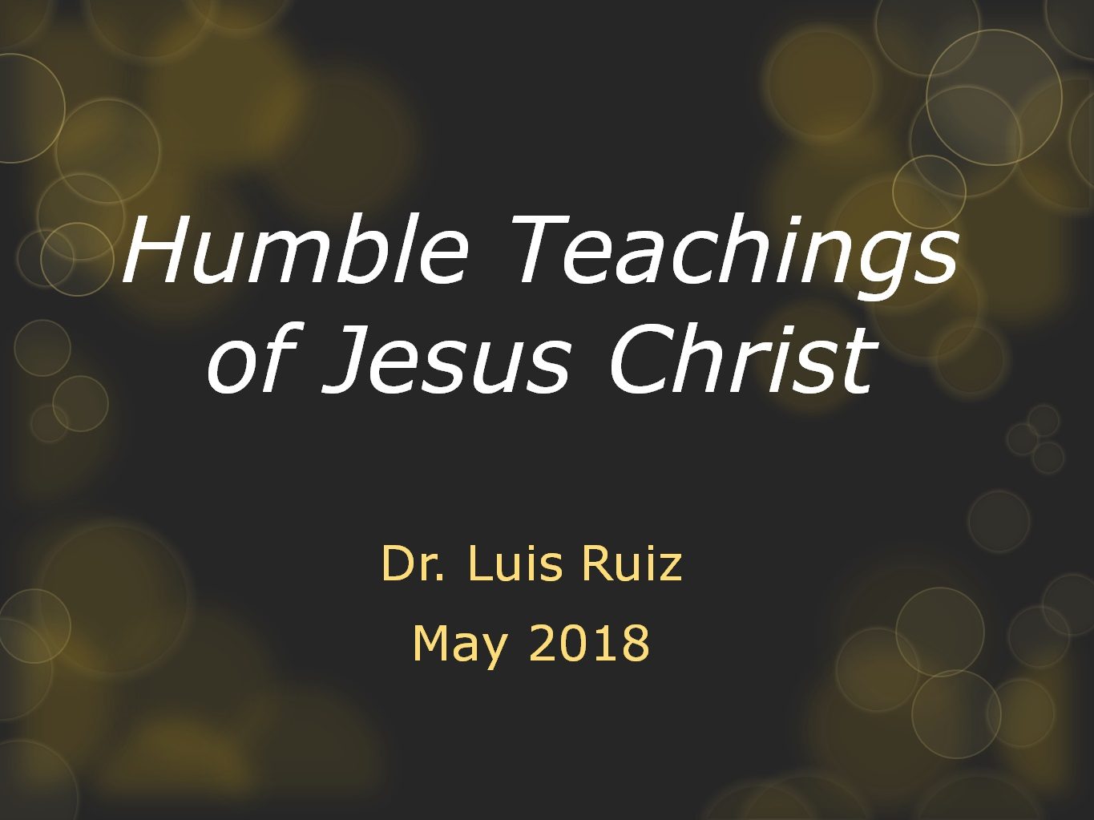
 | 馬太福音 (Matthew) 5:3…
10 | 回應詩  Response |  |  |  |  | #448 |  |  |  |  | 眾立  Cong. Stand
11 | 奉 獻  Offering |  |  |  |  |  |  |  |  |  |  |  |  |  |  | 司獻  Usher
12 | 禱 告  Prayer |  |  |  |  | 眾立  Cong. Stand
13 | 三一頌  Doxology |  |  |  |  |  |  |  | 眾立  Cong. Stand
14 | 祝 福  Benediction |  |  |  |  |  |  |  |  |  |  |  | 盧義思博士  Dr. Ruiz
15 | 阿們頌  Threefold Amen |  |  |  |  |  |  |  |  |  |  | 眾立  Cong. Stand
16 | 殿 樂  Postlude |  |  |  |  |  |  |  |  |  |  |  |  | 司琴  Pianist
BACK
000主在祂的聖殿中
The Lord is in His holy temple
上主今在祂的聖会中,
The Lord is in His holy temple
上主今在祂的聖会中,
The Lord is in His holy temple
萬國的人當肅靜,
Let all the earth keep silence,
萬國的人在主前當肅靜,
Let all the earth keep silence,
before Him,
當肅靜,在主前,應當肅靜。
Keep silence, keep silence,
before Him.
阿門。
Amen.
BACK
诗篇 (Psalm) 95:6, 7
95:6 Come, let us bow down in worship, let us kneel before the Lord our Maker; | 95:6 來啊,我們要屈身敬拜,在造我們的耶和華面前跪下 。
95:7 for he is our God and we are the people of his pasture, the flock under his care. | 95:7 因為祂是我們的神；我們是祂草場的羊,是祂手下的民。惟願你們今天聽祂的話 ：
BACKA
#183美哉主耶穌
Fairest Lord Jesus
===== 1/4 =====
美哉主耶穌，
Fairest Lord Jesus,
宇宙萬物主宰，
ruler of all nature,
祂是真神降世為人：
O Thou of God and man the Son,
我心所景仰，
Thee will I cherish,
我靈所崇敬，
Thee will I honor,
是我榮耀冠冕歡欣。
Thou, my soul's glory, joy, and crown.
===== 2/4 =====
美哉芳草地，
Fair are the meadows,
原野更是美麗，
fairer still the woodlands,
大地披上彩色春衣：
Robed in the blooming garb of spring:
耶穌更美麗，
Jesus is fairer,
耶穌更清潔，
Jesus is purer
使憂傷心發出歌聲。
Who makes the woeful heart to sing.
===== 3/4 =====
陽光多美麗，
Fair is the sunshine,
月光更覺清新，
fairer still the moonlight,
繁星點點燦爛閃耀：
And all the twinkling starry host:
耶穌更光明，
Jesus shines brighter,
耶穌更皎潔，
Jesus shines purer
天使榮光不足比較。
Than all the angels heaven can boast.
===== 4/4 =====
美哉主耶穌，
Beautiful Savior!
統轄萬國萬民！
Lord of all the nations!
世人救主天上真神！
Son of God and Son of Man!
尊貴與光榮，
Glory and honor,
讚美與敬崇，
praise, adoration,
都歸主耶穌到無窮！
Now and forevermore be Thine.

#417 祂何等愛你，愛我
O How He Loves You and Me
===== 1/4 =====
主耶穌何等愛你，
O how He loves you and me!
祂也何等的愛我；
O how He loves you and me!
祂將生命完全的給你。
He gave His life; what more could He give?
祂何等愛你，祂何等愛我，
O how He loves you; O how He loves me;
祂何等愛你，愛我。
O how He loves you and me!
===== 2/2 =====
耶穌曾到骷髏地，
Jesus to Calv’ry did go,
爲愛世人捨自己；
His love for mankind to show.
帶給罪人盼望與生命。
What He did there brought hope from despair.
祂何等愛你 祂何等愛我，
O how He loves you; O how He loves me;
祂何等愛你，愛我，
O how He loves you and me!
BACKB
詩篇 141篇
(Psalms Chapter 141)
141:1 O Lord , I call to you; come quickly to me. Hear my voice when I call to you. | 141:1 〔大衛的詩。〕耶和華阿、我曾求告你．求你快快臨到我這裡．我求告你的時候、願你留心聽我的聲音。
141:2 May my prayer be set before you like incense; may the lifting up of my hands be like the evening sacrifice. | 141:2 願我的禱告、如香陳列在你面前．願我舉手祈求、如獻晚祭。
141:3 Set a guard over my mouth, O Lord ; keep watch over the door of my lips. | 141:3 耶和華阿、求你禁止我的口、把守我的嘴。
141:4 Let not my heart be drawn to what is evil, to take part in wicked deeds with men who are evildoers; let me not eat of their delicacies. | 141:4 求你不叫我的心、偏向邪惡、以致我和作孽的人同行惡事．也不叫我喫他們的美食。
141:5 Let a righteous man strike me-it is a kindness; let him rebuke me-it is oil on my head. My head will not refuse it. Yet my prayer is ever against the deeds of evildoers; | 141:5 任憑義人擊打我、這算為仁慈．任憑他責備我、這算為頭上的膏油．我的頭不要躲閃。正在他們行惡的時候、我仍要祈禱。
141:6 their rulers will be thrown down from the cliffs, and the wicked will learn that my words were well spoken. | 141:6 他們的審判官、被扔在巖下．眾人要聽我的話、因為這話甘甜。
141:7 They will say, "As one plows and breaks up the earth, so our bones have been scattered at the mouth of the grave. " | 141:7 我們的骨頭、散在墓旁、好像人耕田、刨地的土塊。
141:8 But my eyes are fixed on you, O Sovereign Lord ; in you I take refuge-do not give me over to death. | 141:8 主耶和華阿、我的眼目仰望你．我投靠你、求你不要將我撇得孤苦。
141:9 Keep me from the snares they have laid for me, from the traps set by evildoers. | 141:9 求你保護我脫離惡人為我設的網羅、和作孽之人的圈套。
141:10 Let the wicked fall into their own nets, while I pass by in safety. | 141:10 願惡人落在自己的網裡．我卻得以逃脫。
BACKC
#101充滿我
Fill me now
== 1/4 ==
真理聖靈在我心中，
Hover o’er me, Holy Spirit,
自由運行作善工；
Bathe my trembling heart and brow;
發出亮光照耀啟示，
Fill me with Thy hallowed presence,
使我識主並自己。
Come, O come and fill me now.
充滿我！充滿我！
Fill me now, fill me now,
耶穌今來充滿我！
Jesus, come and fill me now;
榮耀聖靈今充滿我，
Fill me with Thy hallowed presence,
願主現今充滿我。
Come, O come, and fill me now.
== 2/4 ==
將我器皿完全倒空，
Thou canst fill me, gracious Spirit,
污穢渣滓除乾淨；
Though I cannot tell Thee how;
用主言語使我成聖，
But I need Thee, greatly need Thee,
平安喜樂常得勝。
Come, O come and fill me now.
充滿我！充滿我！
Fill me now, fill me now,
耶穌今來充滿我！
Jesus, come and fill me now;
榮耀聖靈今充滿我，
Fill me with Thy hallowed presence,
願主現今充滿我。
Come, O come, and fill me now.
== 3/4 ==
有如渴鹿愛慕溪水，
I am weakness, full of weakness,
我心渴慕主恩惠；
At Thy sacred feet I bow;
活水江河願主湧起，
Blest, divine, eternal Spirit,
自我心中流不息。
Fill with power and fill me now.
充滿我！充滿我！
Fill me now, fill me now,
耶穌今來充滿我！
Jesus, come and fill me now;
榮耀聖靈今充滿我，
Fill me with Thy hallowed presence,
願主現今充滿我。
Come, O come, and fill me now.
== 4/4 ==
不是倚靠勢力才能，
Cleanse and comfort, bless and save me,
惟獨仰賴活聖靈；
Bathe, O bathe my heart and brow;
心眼光明靈耳開通，
Thou art comforting and saving,
聖潔器皿合主用。
Thou art sweetly filling now.
充滿我！充滿我！
Fill me now, fill me now,
耶穌今來充滿我！
Jesus, come and fill me now;
榮耀聖靈今充滿我，
Fill me with Thy hallowed presence,
願主現今充滿我。
Come, O come, and fill me now.
BACKD
報 告 事 項
1. 聚會前請將手機關機或是轉為振動，以避免影響聚會進行。
2. 今日崇拜後有茶點，歡迎大家留步同享美好團契.
3. 本周三晚八時於楊孫錦雲姊妹府上舉行查經禱告會，歡迎弟兄姊妹邀約親友踴躍參加 (弟兄姊妹若有代禱事項請聯絡黃牧師)。
4. 下週為聖餐主日,已信主者請預備心領受主的杯和餅,同思主愛. 下週為中英文聯合崇拜.
5. 上主日中英文聯合崇拜奉獻: $918.00, 週一餐館查經班奉獻： $527.00.
BACK
Announcements
1. Before the Service begins, please turn your cell phones to vibrate/silent or off to avoid disturbing the proceedings.
2. We welcome everyone to stay for the refreshments after service.
3. On Wednesday night at 8:00 PM, there will be a Bible Study and prayer at Mrs. Grace Yu’s house.
4. We have Holy Communion next Sunday, may all believers please prepare their heart to remember God’s love.
5. Last week’s offering: $ 918.00.
Monday Bible Study :$ 527.00.
BACKD
#448 深知所信
I Know Whom I Have Believed
==== 1/4 ====
我真不知神的奇恩，
I know not why God’s wondrous grace
为何临到我身，
To me He hath made known,
我也不知不堪如我，
Nor why, unworthy, Christ in love
竟蒙救赎之恩。
Redeemed me for His own.
惟我深知，所信的是谁，
But “I know Whom I have believed,
并且也深信，他实在是能，
And am persuaded that He is able
保守我所信托他的，
To keep that which I’ve committed
都全备直到那日。
Unto Him against that day.”
==== 2/4 ====
我真不知神的奇恩，
I know not how this saving faith
为何临到我身，
To me He did impart,
我也不知不堪如我，
Nor how believing in His Word
竟蒙救赎之恩。
Wrought peace within my heart.
惟我深知，所信的是谁，
But “I know Whom I have believed,
并且也深信，他实在是能，
And am persuaded that He is able
保守我所信托他的，
To keep that which I’ve committed
都全备直到那日。
Unto Him against that day.”
==== 3/4 ====
我真不知圣灵如何，
I know not how the Spirit moves,
引人知道已过，
Convincing men of sin,
并由圣经显明耶稣，
Revealing Jesus through the Word,
使人接他为主。
Creating faith in Him.
惟我深知，所信的是谁，
But “I know Whom I have believed,
并且也深信，他实在是能，
And am persuaded that He is able
保守我所信托他的，
To keep that which I’ve committed
都全备直到那日。
Unto Him against that day.”
==== 4/4 ====
我真不知何时主来，
I know not when my Lord may come,
那时我在何处。
At night or noonday fair,
到底我当经过死谷，
Nor if I walk the vale with Him,
或将空中遇主。
Or meet Him in the air.
惟我深知，所信的是谁，
But “I know Whom I have believed,
并且也深信，他实在是能，
And am persuaded that He is able
保守我所信托他的，
To keep that which I’ve committed
都全备直到那日。
Unto Him against that day.”
BACKE
馬太福音 (Matthew) 5:3
5:3 Blessed are the poor in spirit: for theirs is the kingdom of heaven. | 5:3虛心的人有福了．因為天國是他們的
馬太福音 (Matthew) 18:3 & 18:4
18:3 And said, Verily I say unto you, Except ye be converted, and become as little children, ye shall not enter into the kingdom of heaven. | 18:3說、我實在告訴你們、你們若不回轉、變成小孩子的樣式、斷不得進天國。
18:4 Whosoever therefore shall humble himself as this little child, the same is greatest in the kingdom of heaven. | 18:4所以凡自己謙卑像這小孩子的、他在天國裡就是最大的。
馬太福音(Matthew) 20:27 & 20:28
20:27 And whosoever will be chief among you, let him be your servant: | 20:27誰願為首、就必作你們的僕人．
20:28 Even as the Son of man came not to be ministered unto, but to minister, and to give his life a ransom for many. | 20:28正如人子來、不是要受人的服事、乃是要服事人．並且要捨命、作多人的贖價。
路加福音(Luke) 9:48 & 22:26
9:48 “…Whosoever shall receive this child in my name receiveth me: and whosoever shall receive me receiveth him that sent me: for he that is least among you all, the same shall be great.” | 9:48對他們說、凡為我名接待這小孩子的、就是接待我．凡接待我的、就是接待那差我來的．你們中間最小的、他便為大。
22:26 “…but he that is greatest among you, let him be as the younger; and he that is chief, as he that doth serve.” | 22:26但你們不可這樣．你們裡頭為大的、倒要像年幼的．為首領的、倒要像服事人的。
馬太福音(Matthew) 11:29
11:29 Take my yoke upon you, and learn of me; for I am meek and lowly in heart: and ye shall find rest unto your souls. | 11:29我心裡柔和謙卑、你們當負我的軛、學我的樣式、這樣、你們心裡就必得享安息。
BACKG
#448 深知所信
I Know Whom I Have Believed
==== 1/4 ====
我真不知神的奇恩，
I know not why God’s wondrous grace
为何临到我身，
To me He hath made known,
我也不知不堪如我，
Nor why, unworthy, Christ in love
竟蒙救赎之恩。
Redeemed me for His own.
惟我深知，所信的是谁，
But “I know Whom I have believed,
并且也深信，他实在是能，
And am persuaded that He is able
保守我所信托他的，
To keep that which I’ve committed
都全备直到那日。
Unto Him against that day.”
==== 2/4 ====
我真不知救我的信，
I know not how this saving faith
如何進入我心，
To me He did impart,
我也不知何以一信，
Nor how believing in His Word
便得一個新心。
Wrought peace within my heart.
惟我深知，所信的是谁，
But “I know Whom I have believed,
并且也深信，他实在是能，
And am persuaded that He is able
保守我所信托他的，
To keep that which I’ve committed
都全备直到那日。
Unto Him against that day.”
==== 3/4 ====
我真不知圣灵如何，
I know not how the Spirit moves,
引人知道已过，
Convincing men of sin,
并由圣经显明耶稣，
Revealing Jesus through the Word,
使人接他为主。
Creating faith in Him.
惟我深知，所信的是谁，
But “I know Whom I have believed,
并且也深信，他实在是能，
And am persuaded that He is able
保守我所信托他的，
To keep that which I’ve committed
都全备直到那日。
Unto Him against that day.”
==== 4/4 ====
我真不知何时主来，
I know not when my Lord may come,
那时我在何处。
At night or noonday fair,
到底我当经过死谷，
Nor if I walk the vale with Him,
或将空中遇主。
Or meet Him in the air.
惟我深知，所信的是谁，
But “I know Whom I have believed,
并且也深信，他实在是能，
And am persuaded that He is able
保守我所信托他的，
To keep that which I’ve committed
都全备直到那日。
Unto Him against that day.”
BACK
#256 三一頌
Doxology
===== 1/1 =====
讃美真神萬福之根；
Praise God from whom all blessings flow
世上萬民讃美主恩；
Praise Him all creatures here below
天使天軍讃美主名；
Praise Him above ye heav’nly host
讃美聖父, 聖子, 聖靈
Praise Father Son and Holy Ghost
阿門。
Amen
BACK

