高原地基督教生命堂
主日聯合崇拜
Christian Evangelical Mission Church
in Highland Park
二零一八年六月三日下午一時半
June 3, 2018, 1:30 PM
司會(中)  Chairman: | 黃 明 弟兄  Mr. Ming Huang
講員  Speaker: | 黃 宋 來牧師  Rev. Andrew Wong
翻譯  Translator: | 丁薛芬妮姊妹  Mrs. Fanny Tan
司琴  Pianist: | 李 澤 岳弟兄  Mr. Morgen Li
司琴  Pianist: | 王馮韺韺姊妹  Mrs. Ying Ying Wang
司獻  Usher: | 陳 耀 根弟兄  Mr. Yiu Kan Chan
司獻  Usher: | 林 富 明弟兄  Mr. Ming Lim
清潔  Clean Up: | 洪龔景菲姊妹  Mrs. Jing Fai Hong
清潔  Clean Up: | 凌 秀 菁姊妹  Mrs. Marian Chan
遞聖餐  Communion: | 張 譽 山弟兄  Mr. Yee- San Chang
遞聖餐  Communion: | 黃 明 弟兄  Mr. Ming Huang

1 | 序 樂  Prelude |  |  |  |  |  | 司琴  Pianist
2 | 宣 召  Call to  Worship | 詩篇Psalm  95:6-7. |  |  |  |  |  |  |  |  |  |  |  | 司會  Chairman
3 | 頌讚詩  Hymn of  Praise |  |  | #417 |  |  |  |  | 眾立  Cong. Stand
4 | 祈 禱  Prayer |  |  |  |  |  |  | 司會  Chairman
5 | 讀 經  Scripture  Reading |  | 詩篇141篇  Psalm 141 |  |  |  |  |  |  |  |  |  | 司會  Chairman
6 | 唱 詩  Hymn |  |  |  | #159 |  |  |  |  | 眾立  Cong. Stand
7 | 報 告  Announcement |  |  |  |  |  |  |  |  |  |  |  | 司會  Chairman
8 | 獻 唱  Anthem |  |  |  |  | #317 |  |  | 成人詩班  Adult Choir
9 | 證 道  Sermon |  |  |  |  | 黃宋來牧師  Rev. Wong
 | 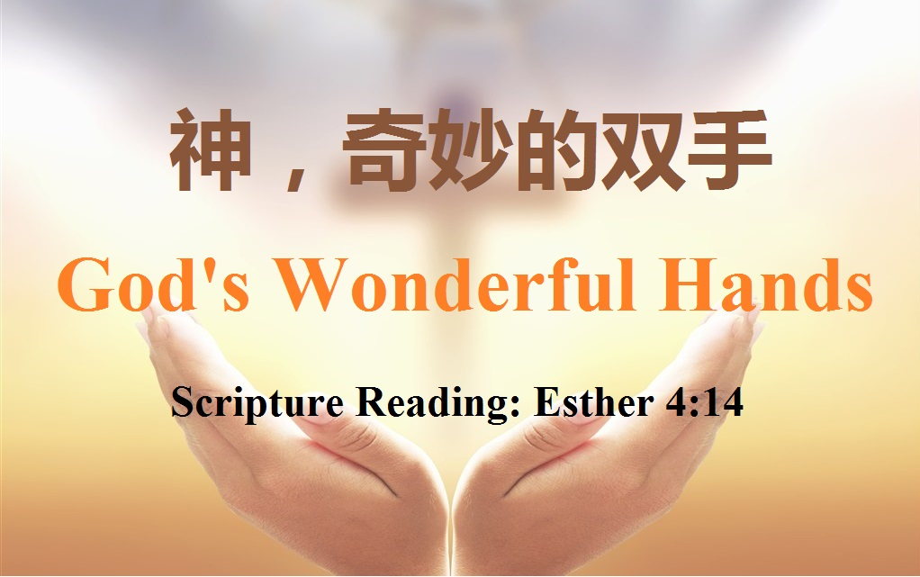
 | 馬以斯帖記 (Esther) 4:14
10 | 回應詩  Response |  |  |  |  | #67 |  |  |  | 眾立  Cong. Stand
11 | 奉 獻  Offering |  |  |  |  |  |  |  |  |  |  |  |  |  | 司獻  Usher
12 | 禱 告  Prayer |  |  |  |  | 眾立  Cong. Stand
13 | 三一頌  Doxology |  |  |  |  |  |  | 眾立  Cong. Stand
14 | 祝 福  Benediction |  |  |  |  |  |  |  |  |  |  | 黃宋來牧師  Rev. Wong
15 | 阿們頌  Threefold Amen |  |  |  |  |  |  |  |  |  | 眾立  Cong. Stand
16 | 殿 樂  Postlude |  |  |  |  |  |  |  |  |  |  |  | 司琴  Pianist
BACK
000主在祂的聖殿中
The Lord is in His holy temple
上主今在祂的聖会中,
The Lord is in His holy temple
上主今在祂的聖会中,
The Lord is in His holy temple
萬國的人當肅靜,
Let all the earth keep silence,
萬國的人在主前當肅靜,
Let all the earth keep silence,
before Him,
當肅靜,在主前,應當肅靜。
Keep silence, keep silence,
before Him.
阿門。
Amen.
BACK
诗篇 (Psalm) 95:6, 7
95:6 Come, let us bow down in worship, let us kneel before the Lord our Maker; | 95:6 來啊,我們要屈身敬拜,在造我們的耶和華面前跪下 。
95:7 for he is our God and we are the people of his pasture, the flock under his care. | 95:7 因為祂是我們的神；我們是祂草場的羊,是祂手下的民。惟願你們今天聽祂的話 ：
BACKA
#417 祂何等愛你，愛我
O How He Loves You and Me
===== 1/4 =====
主耶穌何等愛你，
O how He loves you and me!
祂也何等的愛我；
O how He loves you and me!
祂將生命完全的給你。
He gave His life; what more could He give?
祂何等愛你，祂何等愛我，
O how He loves you; O how He loves me;
祂何等愛你，愛我。
O how He loves you and me!
===== 2/2 =====
耶穌曾到骷髏地，
Jesus to Calv’ry did go,
爲愛世人捨自己；
His love for mankind to show.
帶給罪人盼望與生命。
What He did there brought hope from despair.
祂何等愛你 祂何等愛我，
O how He loves you; O how He loves me;
祂何等愛你，愛我，
O how He loves you and me!
BACKB
詩篇 141篇
(Psalms Chapter 141)
141:1 O Lord , I call to you; come quickly to me. Hear my voice when I call to you. | 141:1 〔大衛的詩。〕耶和華阿、我曾求告你．求你快快臨到我這裡．我求告你的時候、願你留心聽我的聲音。
141:2 May my prayer be set before you like incense; may the lifting up of my hands be like the evening sacrifice. | 141:2 願我的禱告、如香陳列在你面前．願我舉手祈求、如獻晚祭。
141:3 Set a guard over my mouth, O Lord ; keep watch over the door of my lips. | 141:3 耶和華阿、求你禁止我的口、把守我的嘴。
141:4 Let not my heart be drawn to what is evil, to take part in wicked deeds with men who are evildoers; let me not eat of their delicacies. | 141:4 求你不叫我的心、偏向邪惡、以致我和作孽的人同行惡事．也不叫我喫他們的美食。
141:5 Let a righteous man strike me-it is a kindness; let him rebuke me-it is oil on my head. My head will not refuse it. Yet my prayer is ever against the deeds of evildoers; | 141:5 任憑義人擊打我、這算為仁慈．任憑他責備我、這算為頭上的膏油．我的頭不要躲閃。正在他們行惡的時候、我仍要祈禱。
141:6 their rulers will be thrown down from the cliffs, and the wicked will learn that my words were well spoken. | 141:6 他們的審判官、被扔在巖下．眾人要聽我的話、因為這話甘甜。
141:7 They will say, "As one plows and breaks up the earth, so our bones have been scattered at the mouth of the grave. " | 141:7 我們的骨頭、散在墓旁、好像人耕田、刨地的土塊。
141:8 But my eyes are fixed on you, O Sovereign Lord ; in you I take refuge-do not give me over to death. | 141:8 主耶和華阿、我的眼目仰望你．我投靠你、求你不要將我撇得孤苦。
141:9 Keep me from the snares they have laid for me, from the traps set by evildoers. | 141:9 求你保護我脫離惡人為我設的網羅、和作孽之人的圈套。
141:10 Let the wicked fall into their own nets, while I pass by in safety. | 141:10 願惡人落在自己的網裡．我卻得以逃脫。
BACKC
#159 祂名稱為奇妙
His Name is Wonderful
===== 1/1 =====
祂名稱為奇妙，祂名稱為奇妙，
His name is wonderful, His name is wonderful,
祂名稱為奇妙，耶穌我主；
His name is wonderful, Jesus my Lord.
祂是全能君王，祂是萬有之主，
He is the mighty King, master of everything,
祂名稱為奇妙，耶穌我主。
His name is wonderful, Jesus my Lord.
祂是好牧者，是萬古的磐石，
He's the Great Shephard, The Rock of all ages,
祂是全能的神；
Almighty God is he,
當伏在主前，敬愛崇拜祂，
Bow down before Him, Love and adore Him,
祂名稱為奇妙，耶穌我主。
His name is wonderful, Jesus my Lord.
BACKD
報 告 事 項
1. 今日為聖餐主日,已信主者請預備心領受主的杯和餅,同思主愛.
2. 今日崇拜後有茶點,歡迎大家留步同享美好團契.
3. 明晚八時瑜練蔡嬌伯母府上舉行查經聚會,歡迎弟兄姊妹踴躍參加.
4. 本週三晚八時於楊孫錦雲姊妹府上舉行查經禱告會,歡迎弟兄姊妹踴躍參加.
5. 本週五晚七時三刻於陳鼎瑜伉儷府上舉行青年團契,歡迎青少年踴躍參加..
6. 錫安團契將於七月十七日(主日)晚七時半在謝定全弟兄伉儷府上舉行,歡迎弟兄姊妹踴躍參加
7. 總會定於八月十八日舉行生命堂聯合運動會,有興趣者請預留時間參加.
8. 上主日中英文聯合崇拜奉獻:$ .416.00.
BACK
Announcements
1. We have Holy Communion today. May all believers prepare your hearts to remember God’s love.
2. Today after the Sunday worship, we will have refreshments in the Blue room. Please stay to have fellowship with one another
3. Tomorrow night at 8:00PM, we will have a Bible Study at Mrs. Chai Kiu Lim’s house..
4. On Wednesday night at 8 PM, there will have a bible study and prayer meeting at Mrs. Grace Yu’s house.
5. On Friday at 7:45PM there will be a youth fellowship at Mr. & Mrs. Ding Chan’s house.
6. Today after the Sunday worship, we will have refreshments in the Blue room. Please stay to have fellowship with one another
7. Tomorrow night at 8:00PM, we will have a Bible Study at Mrs. Chai Kiu Lim’s house..
8. On Wednesday night at 8 PM, there will have a bible study and prayer meeting at Mrs. Grace Yu’s house.
BACKD
#317 我受死，是为祢的眼淚
For Those Tears I Died
===== 1/3 =====
祢曾說祢要來，與我分擔憂傷，
You said You'd come and share all my sorrows,
祢說祢會同在，解我明天惆帳；
You said You'd be there for all my tomorrows;
我幾乎拒絕，不願讓祢進來，
I came so close to sending You away,
但正如祢應許，祢已經進來，
But just like You promised You came there to stay--
祢與我同在。
I just had to pray.
主耶穌說，"來到我身旁，
And Jesus said, "Come to the water,
飲我活水，我知道祢乾渴，
Stand by My side; I know you are thirsty,
请不要拒絕，祢黑夜裡哭泣，
You won't be denied.
我也為祢落淚，深願祢知我受死，
I felt ev'ry tear drop when in darkness you cried,
是為祢的眼淚。"
And I strove to remind you that for those tears I died."
===== 2/3 =====
主愛何等偉大，我真不能明白，
Your goodness so great I can't understand,
親愛主，我知道，是祢計劃安排；
And dear Lord I know that all this was planned:
祢與我同在，永遠不會離開，
I know You're here now, and always will be,
我會得著自由，都因祢的愛，
Your love loosed my chains and in You I'm free--
我蒙了大愛。
But Jesus why me
主耶穌說，"來到我身旁，
And Jesus said, "Come to the water,
飲我活水，我知道祢乾渴，
Stand by My side; I know you are thirsty,
请不要拒絕，
You won't be denied.
祢黑夜裡哭泣，我也為祢落淚，
I felt ev'ry tear drop when in darkness you cried,
深願祢知我受死，是為祢的眼淚。"
And I strove to remind you that for those tears I died."
===== 3/3 =====
主耶穌我願意，奉獻我的心靈，
Jesus I give You my heart and my soul,
我知道離了祢，我無法得潔淨；
I know that without God I'd never be whole;
救主禰為我，已打開了門戶，
Savior You opened All the right doors,
我願感謝讚美，虔誠敬拜主，
And I thank You and praise You from earth's humble shores--
我永遠屬於主。
Take me I'm Yours
主耶穌說，"來到我身旁，
And Jesus said, "Come to the water,
飲我活水，我知道祢乾渴，
Stand by My side; I know you are thirsty,
请不要拒絕，祢黑夜裡哭泣，
You won't be denied.
我也為祢落淚，深願祢知我受死，
I felt ev'ry tear drop when in darkness you cried,
是為祢的眼淚。"
And I strove to remind you that for those tears I died."
BACKE
以斯帖記 (Esther) 4:14
4:14 For if you remain silent at this time, relief and deliverance for the Jews will arise from another place, but you and your father's family will perish. And who knows but that you have come to royal position for such a time as this?" | 4:14 此時你若閉口不言、猶大人必從別處得解脫、蒙拯救、你和你父家、必致滅亡．焉知你得了王后的位分、不是為現今的機會麼。
BACKG
#67 在十架
At The Cross
===== 1/4 =====
可嘆，我主流出寶血，
Alas! and did my Savior bleed?
甘願為我捨身。
And did my Sov'reign die?
忍受痛苦歷盡艱辛，
Would He devote that sacred head
救我卑微罪人。
For someone such as I?
在十架，在十架，
At the cross, at the cross,
我一見主恩光，
Where I first saw the light,
我心中罪孽重擔皆脫落，
And the burden of my heart rolled away -
在我主十架，我因信眼明亮，
It was there by faith I received my sight,
如今我心常歡喜快樂。
And now I am happy all the day.
===== 2/4 =====
我主受苦在十字架上，
Was it for crimes that I have done
為我所犯罪衍。
He suffered on the tree?
何等慈悲無量恩典，
Amazing pity! Grace unknown!
主愛廣大無邊。
And love beyond degree!
在十架，在十架，
At the cross, at the cross,
我一見主恩光，
Where I first saw the light,
我心中罪孽重擔皆脫落，
And the burden of my heart rolled away -
在我主十架，我因信眼明亮，
It was there by faith I received my sight,
如今我心常歡喜快樂。
And now I am happy all the day.
===== 3/4 =====
正當基督造物的主，
Well might the sun in darkenss hide
為人罪過身亡。
And shut his glories in,
輝煌紅日也被隱藏，
When Christ, the mighty Maker, died
天地黑暗無光。
For man the creature's sin.
在十架，在十架，
At the cross, at the cross,
我一見主恩光，
Where I first saw the light,
我心中罪孽重擔皆脫落，
And the burden of my heart rolled away -
在我主十架，我因信眼明亮，
It was there by faith I received my sight,
如今我心常歡喜快樂。
And now I am happy all the day.
===== 4/4 =====
我雖流盡傷心眼淚，
But drops of grief can ne'er repay
難還主愛的債。
The debt of love I owe:
只將身心獻為活祭，
Here, Lord, I give myself away -
藉報救主大愛。
'Tis all that I can do!
在十架，在十架，
At the cross, at the cross,
我一見主恩光，
Where I first saw the light,
我心中罪孽重擔皆脫落，
And the burden of my heart rolled away -
在我主十架，我因信眼明亮，
It was there by faith I received my sight,
如今我心常歡喜快樂。
And now I am happy all the day.
BACK
#256 三一頌
Doxology
===== 1/1 =====
讃美真神萬福之根；
Praise God from whom all blessings flow
世上萬民讃美主恩；
Praise Him all creatures here below
天使天軍讃美主名；
Praise Him above ye heav’nly host
讃美聖父, 聖子, 聖靈
Praise Father Son and Holy Ghost
阿門。
Amen
BACK

