高原地基督教生命堂
主日聯合崇拜
Christian Evangelical Mission Church
in Highland Park
二零一八年七月二十九日下午一時半
July 29, 2018, 1:30 PM
司會  Chairman: | 練戴秀群姊妹  Mrs. Siew Kuan Lim
講員  Speaker: | 黃 宋 來牧師  Rev. Andrew Wong
翻譯  Translator: | 丁薛芬妮姊妹  Mrs. Fanny Tan
司琴  Pianist: | 李 澤 岳弟兄  Mr. Morgen Li
司琴  Pianist: | 王馮韺韺姊妹  Mrs. Ying Ying Wang
司獻  Usher: | 王 培 仁弟兄  Mr. Pei–Ren Wang
司獻  Usher: | 凌 偉 歡弟兄  Mr. Morgen Li g
清潔  Clean Up: | 陳 耀 根弟兄  Mr. Yiu - Kan Chan
清潔  Clean Up: | 練戴秀群姊妹  Mrs. Siew Kuan Lim

1 | 序 樂  Prelude |  |  |  |  |  | 司琴  Pianist
2 | 宣 召  Call to  Worship | 詩篇Psalm  95:6-7. |  |  |  |  |  |  |  |  |  |  |  |  | 司會  Chairman
3 | 頌讚詩  Hymn of  Praise |  | #501 (x2) |  |  |  |  |  |  |  |  | 眾立  Cong. Stand
4 | 祈 禱  Prayer |  |  |  |  |  |  | 司會  Chairman
5 | 讀 經  Scripture  Reading |  | 詩篇(Psalm)  148 |  |  |  |  |  |  |  |  |  |  | 司會  Chairman
6 | 唱 詩  Hymn |  |  |  | #510 |  |  |  |  | 眾立  Cong. Stand
7 | 報 告  Announcement |  |  |  |  |  |  |  |  |  |  |  |  | 司會  Chairman
8 | 獻 唱  Anthem |  |  | #438 |  |  |  |  |  |  |  |  | 成人詩班  Adult Choir
9 | 證 道  Sermon |  |  |  |  | 黃宋來牧師  Rev .Wong
耶穌如何勝過試探
How Jesus
Overcame Temptation
 | 馬太福音 (Matthew) 4:1-11
10 | 回應詩  Response |  |  |  |  | #295 |  |  |  | 眾立  Cong. Stand
11 | 奉 獻  Offering |  |  |  |  |  |  |  |  |  |  |  |  |  |  | 司獻  Usher
12 | 禱 告  Prayer |  |  |  |  | 眾立  Cong. Stand
13 | 三一頌  Doxology |  |  |  |  |  |  | 眾立  Cong. Stand
 | 祝 福  Benediction |  |  |  |  |  |  |  |  |  |  | 黃宋來牧師  Rev. Wong
15 | 阿們頌  Threefold Amen |  |  |  |  |  |  |  |  |  | 眾立  Cong. Stand
16 | 殿 樂  Postlude |  |  |  |  |  |  |  |  |  |  |  |  | 司琴  Pianist
BACK

000主在祂的聖殿中
The Lord is in His holy temple
===== 1/1 =====
上主今在祂的聖会中,
The Lord is in His holy temple
上主今在祂的聖会中,
The Lord is in His holy temple
萬國的人當肅靜,
Let all the earth keep silence,
萬國的人在主前當肅靜,
Let all the earth keep silence,
before Him,
當肅靜,在主前,應當肅靜。
Keep silence, keep silence,
before Him.
阿門。
Amen.
BACK
诗篇 (Psalm) 95:6, 7
95:6 Come, let us bow down in worship, let us kneel before the Lord our Maker; | 95:6 來啊,我們要屈身敬拜,在造我們的耶和華面前跪下 。
95:7 for he is our God and we are the people of his pasture, the flock under his care. | 95:7 因為祂是我們的神；我們是祂草場的羊,是祂手下的民。惟願你們今天聽祂的話 ：
BACKA
501至高真神
Be Exalted, O God
== 1/2 ==
我要向祢稱謝，
I will give thanks to Thee
哦，主，在萬民當中。
O Lord, among the people
我要讚美祢的名
I will sing praises to Thee
在列邦之中。
Among the nations
祢的慈愛不改變，
For Thy steadfast love is great
慈愛高過諸天，
Is great to the heavens
祢的信實，
And Thy faithfulness
祢的信實達到穹蒼。
Thy faithfulness to the clouds
至高真神，哦，主，
Be exalted, O God
我願尊崇祢。
Above the heavens
祢的榮耀與崇高高過天地。
Let Thy glory be over all the earth
至高真神，哦，主，
Be exalted, O God
我願尊崇祢。
Above the heavens
祢的榮耀與崇高高過天地。
Let Thy glory be over all the earth
== 2/2 ==
我要向祢稱謝，
I will give thanks to Thee
哦，主，在萬民當中。
O Lord, among the people
我要讚美祢的名
I will sing praises to Thee
在列邦之中。
Among the nations
祢的慈愛不改變，
For Thy steadfast love is great
慈愛高過諸天，
Is great to the heavens
祢的信實，
And Thy faithfulness
祢的信實達到穹蒼。
Thy faithfulness to the clouds
至高真神，哦，主，
Be exalted, O God
我願尊崇祢。
Above the heavens
祢的榮耀與崇高高過天地。
Let Thy glory be over all the earth
至高真神，哦，主，
Be exalted, O God
我願尊崇祢。
Above the heavens
祢的榮耀與崇高高過天地。
Let Thy glory be over all the earth
BACKB
詩篇 148
(Psalms Chapter 148)
148:1 Praise the Lord . Praise the Lord from the heavens, praise him in the heights above. | 148:1 你們要讚美耶和華、從天上讚美耶和華、在高處讚美他。
148:2 Praise him, all his angels, praise him, all his heavenly hosts. | 148:2 他的眾使者都要讚美他．他的諸軍都要讚美他。
148:3 Praise him, sun and moon, praise him, all you shining stars. | 148:3 日頭月亮、你們要讚美他．放光的星宿、你們都要讚美他。
148:4 Praise him, you highest heavens and you waters above the skies. | 148:4 天上的天、和天上的水、你們都要讚美他。
148:5 Let them praise the name of the Lord , for he commanded and they were created. | 148:5 願這些都讚美耶和華的名．因他一吩咐便都造成。
148:6 He set them in place for ever and ever; he gave a decree that will never pass away. | 148:6 他將這些立定、直到永永遠遠．他定了命、不能廢去。〔廢去或作越過〕
148:7 Praise the Lord from the earth, you great sea creatures and all ocean depths, | 148:7 所有在地上的、大魚和一切深洋、
148:8 lightning and hail, snow and clouds, stormy winds that do his bidding, | 148:8 火與冰雹、雪和霧氣、成就他命的狂風、
148:9 you mountains and all hills, fruit trees and all cedars, | 148:9 大山和小山、結果的樹木、和一切香柏樹、
148:10 wild animals and all cattle, small creatures and flying birds, | 148:10 野獸和一切牲畜、昆蟲和飛鳥、
148:11 kings of the earth and all nations, you princes and all rulers on earth, | 148:11 世上的君王和萬民、首領和世上一切審判官、
148:12 young men and maidens, old men and children. | 148:12 少年人和處女、老年人和孩童、都當讚美耶和華。
148:13 Let them praise the name of the Lord , for his name alone is exalted; his splendor is above the earth and the heavens. | 148:13 願這些都讚美耶和華的名．因為獨有他的名被尊崇．他的榮耀在天地之上。
148:14 He has raised up for his people a horn, the praise of all his saints, of Israel, the people close to his heart. Praise the Lord . | 148:14 他將他百姓的角高舉．因此他〔因此他或作他使〕一切聖民以色列人、就是與他相近的百姓、都讚美他。你們要讚美耶和華。
BACKC
#510 先求神的国
Seek ye first
===== 1/2 =====
你们要先求祂的国，
Seek ye first the kingdom of God
先求祂的义，
And His righteousness;
这些东西祂都要加给你们。
And all these things shall be added unto you.
阿利路，阿利路亚。
Hallelu, Hallelujah!
===== 2/2 =====
你们祈求就必给你们，
Ask, and it shall be given unto you;
寻找，就寻见。
Seek, and you shall find.
叩门的就必给你们开门
Knock, and it shall be opened unto you.
阿利路，阿利路亚。
Hallelu, Hallelujah!
BACKD
報 告 事 項
1. 今日崇拜後有茶點,歡迎大家留步同享美好團契.
2. 聚會前請將手機關機或是轉為振動,以免影響聚會進行.
3. 本週三晚八時於楊孫錦雲姊妹府上有查經禱告會, 歡迎弟兄姊妹踴躍參加（弟兄姊妹若有代禱事項請聯絡黃牧師）
4. 下主日為總會五十週年慶典, 本堂會崇拜暫停一次, 08/12恢復崇拜聚會.
5. 美東區生命堂聯合運動會於08/18/2018,上午九時至下午五時在多華谷多功能建築舉行,有意參加者請早日報名.網址:
https://goo.gl/forms/owf5pzcp2yuixso23
6. 上主日中英文聯合崇拜奉獻: $ 698.00.週一餐館查經班奉獻: $ 417.00.
BACK
Announcements
1. Today after service, we will have refreshments in the Blue Room. Please stay to have fellowship with one another.
2. Before the Service begins, please turn your cell phones to vibrate/silent or off to avoid disturbing the proceedings.
3. On Wednesday night at 8:00PM, we will have a Bible Study and prayer meeting at Mrs. Grace Yu’s house.
4. There is no service on next Sunday due of EMSI 50th anniversary celebration at Towaco.
5. The East Coast CEM Sports Day will be held on Aug.18th starting at 9AM to 5PM,at Towaco Church, if you’re interested ,please fill out the following from.
https://goo.gl/forms/owf5pzcp2yuixso23
6. Last week’s offering: $ 698.00.
Monday Bible Study offering : $ 417.00.
BACKD
#438 救主是我一切
He's Everything to Me
===== 1/2 =====
群星閃耀述說主奇工，
In the stars His handiwork I see,
微風吹動見證主尊榮;
On the wind He speaks with majesty;
陸地海洋在祂掌管中，
Though He ruleth over land and sea,
對我有何意？
What is that to me?
直到憑信見主面對面，
'Til by faith I met Him face to face
領會救主奇妙大恩典，
And I felt the wonder of His grace,
我才深知真神愛無邊，
Then I knew that He was more
他時刻關懷我，
Than just a God who didn't care,
並非遠住在高天，
That lived away out there,
每日與我同行肩並肩，
And now He walks beside me day by day,
常常看顧我免遭危險，
Ever watching o'er me lest I stray,
助我走窄路勇往直前，
Helping me to find that narrow way,
救主是我一切,
He's ev'rything to me.
===== 2/2 =====
救主降生要慶祝歌頌，
I will celebrate nativity,
因這事已記載歷史中;
For it has a place in history;
祂來世界使人得自由，
Sure, He came to set His people free,
對我有何意？
What is that to me?
直到憑信見主面對面，
'Til by faith I met Him face to face
領會救主奇妙大恩典，
And I felt the wonder of His grace,
我才深知真神愛無邊，
Then I knew that He was more
他時刻關懷我，
Than just a God who didn't care,
並非遠住在高天，
That lived away out there,
每日與我同行肩並肩，
And now He walks beside me day by day,
常常看顧我免遭危險，
Ever watching o'er me lest I stray,
助我走窄路勇往直前，
Helping me to find that narrow way,
救主是我一切。
He's ev'rything to me.
BACKE
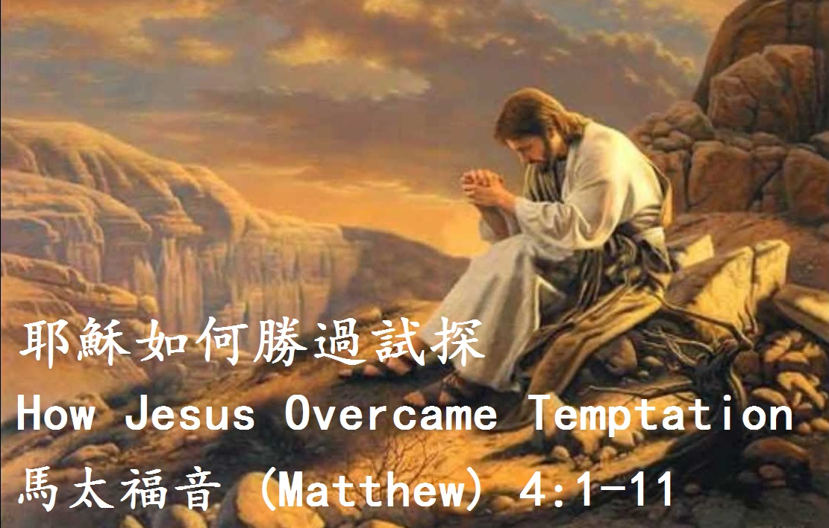

馬太福音 (Matthew) 4:1-11
4:1 Then Jesus was led by the Spirit into the desert to be tempted by the devil. | 4:1 當時、耶穌被聖靈引到曠野、受魔鬼的試探。
4:2 After fasting forty days and forty nights, he was hungry. | 4:2 他禁食四十晝夜、後來就餓了。
4:3 The tempter came to him and said, "If you are the Son of God, tell these stones to become bread." | 4:3 那試探人的進前來、對他說、你若是 神的兒子、可以吩咐這些石頭變成食物。
4:4 Jesus answered, "It is written: 'Man does not live on bread alone, but on every word that comes from the mouth of God.' " | 4:4 耶穌卻回答說、經上記著說、『人活著、不是單靠食物、乃是靠 神口裡所出的一切話。』
4:5 Then the devil took him to the holy city and had him stand on the highest point of the temple. | 4:5 魔鬼就帶他進了聖城、叫他站在殿頂上、〔頂原文作翅〕
4:6 "If you are the Son of God," he said, "throw yourself down. For it is written: " 'He will command his angels concerning you, and they will lift you up in their hands, so that you will not strike your foot against a stone.' " | 4:6 對他說、你若是 神的兒子、可以跳下去．因為經上記著說、『主要為你吩咐他的使者、用手托著你、免得你的腳碰在石頭上。』
4:7 Jesus answered him, "It is also written: 'Do not put the Lord your God to the test.' " | 4:7 耶穌對他說、經上又記著說、『不可試探主你的 神。』
4:8 Again, the devil took him to a very high mountain and showed him all the kingdoms of the world and their splendor. | 4:8 魔鬼又帶他上了一座最高的山、將世上的萬國、與萬國的榮華、都指給他看、
4:9 "All this I will give you," he said, "if you will bow down and worship me." | 4:9 對他說、你若俯伏拜我、我就把這一切都賜給你。
4:10 Jesus said to him, "Away from me, Satan! For it is written: 'Worship the Lord your God, and serve him only.' " | 4:10 耶穌說、撒但退去罷。〔撒但就是抵擋的意思乃魔鬼的別名〕因為經上記著說、『當拜主你的 神、單要事奉他。』
4:11 Then the devil left him, and angels came and attended him. | 4:11 於是魔鬼離了耶穌、有天使來伺候他。
BACKG
#295 奉獻上好
Our Best
==== 1/3 ====
請聽救主呼召，“奉獻上好，”
Hear ye the Master's call, "Give Me thy best!"
處卑微或升高，主必察考；
For, be it great or small, that is His test.
盡你才力所能，不求酬報，
Do then the best you can, not for reward,
不須求人稱贊，因主知道。
Not for the praise of men, but for the Lord.
凡為耶穌所作都蒙福，
Every work for Jesus will be blest,
恩主要人人全力以赴，
But He asks from everyone his best.
我才力雖微小，不足稱道，
Our talents may be few, these may be small,
祗求盡心盡意盡力愛主。
But unto Him is due our best, our all.
==== 2/3 ====
不要等人稱贊，心被動搖，
Wait not for men to laud, heed not their slight;
但求父神喜悅，使神歡笑；
Winning the smile of God brings its delight!
凡事求善求真．不作競爭，
Aiding the good and true ne'er goes unblest,
不論行走思想，當盡所能。
All that we think or do, be it the best.
凡為耶穌所作都蒙福，
Every work for Jesus will be blest,
恩主要人人全力以赴，
But He asks from everyone his best.
我才力雖微小，不足稱道，
Our talents may be few, these may be small,
祗求盡心盡意盡力愛主。
But unto Him is due our best, our all.
==== 3/3 ====
黑夜迅速過去，時日似箭，
Night soon comes on apace, day hastens by;
今日所作之工，主要考驗；
Workman and work must face testing on high.
盼望主再來時，永享安寧，
Oh, may we in that day find rest, sweet rest,
主曾應許賜福盡忠僕人。
Which God has promised those who do their best.
凡為耶穌所作都蒙福，
Every work for Jesus will be blest,
恩主要人人全力以赴，
But He asks from everyone his best.
我才力雖微小，不足稱道，
Our talents may be few, these may be small,
祗求盡心盡意盡力愛主。
But unto Him is due our best, our all.
BACK
#256 三一頌
Doxology
===== 1/1 =====
讃美真神萬福之根；
Praise God from whom all blessings flow
世上萬民讃美主恩；
Praise Him all creatures here below
天使天軍讃美主名；
Praise Him above ye heav’nly host
讃美聖父, 聖子, 聖靈
Praise Father Son and Holy Ghost
阿門。
Amen
BACK

