高原地基督教生命堂
主日聯合崇拜
Christian Evangelical Mission Church
in Highland Park
二零一八年八月十二日下午一時半
Aug. 12, 2018, 1:30 PM
司會 (中)  Chairman: | 劉 秀 芝姊妹  Mrs. Ella Liu
司會 (英)  Chairman: | 謝 家 寧姊妹  Miss. Janine Shieh
講員  Speaker: | 黃 健 中弟兄  Mr. Kenny Wong
翻譯  Translator: | 謝 徐 穎姊妹  Mrs. Ying Shieh
司琴  Pianist: | 李 澤 岳弟兄  Mr. Morgen Li
司琴  Pianist: | 王馮韺韺姊妹  Mrs. Ying Ying Wang
司獻  Usher: | 王 培 仁弟兄  Mr. Pei–Ren Wang
司獻  Usher: | 王 強 弟兄  Mr. Charlie Wang
清潔  Clean Up: | 練林瑞玉姊妹  Mrs. Swee Yoke Lim
清潔  Clean Up: | 凌 秀 菁姊妹  Mrs. Marian Chan

1 | 序 樂  Prelude |  |  |  |  |  | 司琴  Pianist
2 | 宣 召  Call to  Worship | 詩篇Psalm  95:6-7. |  |  |  |  |  |  |  |  |  |  |  |  | 司會  Chairman
3 | 頌讚詩  Hymn of  Praise |  | #503 |  |  |  |  |  |  |  |  | 眾立  Cong. Stand
4 | 祈 禱  Prayer |  |  |  |  |  |  | 司會  Chairman
5 | 讀 經  Scripture  Reading |  | 詩篇(Psalm)  147:1-10 |  |  |  |  |  |  |  |  |  |  | 司會  Chairman
6 | 唱 詩  Hymn |  |  |  | #438 |  |  |  |  | 眾立  Cong. Stand
7 | 報 告  Announcement |  |  |  |  |  |  |  |  |  |  |  |  | 司會  Chairman
8 | 獻 唱  Anthem |  |  | #457 |  |  |  |  |  |  |  |  | 成人詩班  Adult Choir
9 | 證 道  Sermon |  |  |  |  | 黃健中弟兄  Mr. Wong
你错过了上帝最好的祝福吗?
Are You Missing
God’s Best Blessings
 | 出埃及記 (Exodus) 4: 10-14
10 | 回應詩  Response |  |  |  |  | #416 |  |  |  | 眾立  Cong. Stand
11 | 奉 獻  Offering |  |  |  |  |  |  |  |  |  |  |  |  |  |  | 司獻  Usher
12 | 禱 告  Prayer |  |  |  |  | 眾立  Cong. Stand
13 | 三一頌  Doxology |  |  |  |  |  |  | 眾立  Cong. Stand
 | 祝 福  Benediction |  |  |  |  |  |  |  |  |  |  | 黃宋來牧師  Rev. Wong
15 | 阿們頌  Threefold Amen |  |  |  |  |  |  |  |  |  | 眾立  Cong. Stand
16 | 殿 樂  Postlude |  |  |  |  |  |  |  |  |  |  |  |  | 司琴  Pianist
BACK
000主在祂的聖殿中
The Lord is in His holy temple
===== 1/1 =====
上主今在祂的聖会中,
The Lord is in His holy temple
上主今在祂的聖会中,
The Lord is in His holy temple
萬國的人當肅靜,
Let all the earth keep silence,
萬國的人在主前當肅靜,
Let all the earth keep silence,
before Him,
當肅靜,在主前,應當肅靜。
Keep silence, keep silence,
before Him.
阿門。
Amen.
BACK
诗篇 (Psalm) 95:6, 7
95:6 Come, let us bow down in worship, let us kneel before the Lord our Maker; | 95:6 來啊,我們要屈身敬拜,在造我們的耶和華面前跪下 。
95:7 for he is our God and we are the people of his pasture, the flock under his care. | 95:7 因為祂是我們的神；我們是祂草場的羊,是祂手下的民。惟願你們今天聽祂的話 ：
BACKA
#503 榮耀歸萬王之王
We Will Glorify
===== 1/4 =====
一切榮耀歸萬王之王
We will glorify the King of kings,
榮耀歸被殺羔羊，
We will glorify the Lamb;
一切榮耀歸萬主之主，
We will glorify the Lord of lords,
祂是偉大的真神。
Who is the great I am.
===== 2/4 =====
主耶和華掌權有威嚴，
Lord Jehovah reigns in majesty,
寶座前栽願敬拜，
We will bow before His throne;
以誠實公義來敬拜祂，
We will worship Him in righteousness,
單單要向祂敬拜。
We will worship Him alone.
===== 3/4 =====
祂是天和地的大主宰，
He is Lord of Heaven, Lord of Earth,
祂是世人的救主，
He is Lord of all who live;
祂是至高主超過萬物，
He is Lord above the universe,
配受讚美與尊崇。
All praise to Him we give.
===== 4/4 =====
哈利路亞歸萬王之王，
Hallelujah to the King of kings,
哈利路亞歸羔羊，
Hallelujah to the Lamb;
哈利路亞歸萬主之主，
Hallelujah to the Lord of lords,
祂是偉大的真神。
Who is the great I am.
BACKB
詩篇 147:1-10
(Psalms Chapter 147:1-10)
147:1 Praise the Lord . How good it is to sing praises to our God, how pleasant and fitting to praise him!. | 147:1 你們要讚美耶和華、因歌頌我們的 神為善為美．讚美的話是合宜的。
147:2 The Lord builds up Jerusalem; he gathers the exiles of Israel. | 147:2 耶和華建造耶路撒冷、聚集以色列中被趕散的人。
147:3 He heals the brokenhearted and binds up their wounds. | 147:3 他醫好傷心的人、裹好他們的傷處。。
147:4 He determines the number of the stars and calls them each by name. | 147:4 他數點星宿的數目、一一稱他的名。
147:5 Great is our Lord and mighty in power; his understanding has no limit. | 147:5 我們的主為大、最有能力．他的智慧、無法測度。
147:6 The Lord sustains the humble but casts the wicked to the ground. | 147:6 耶和華扶持謙卑人、將惡人傾覆於地。
147:7 Sing to the Lord with thanksgiving; make music to our God on the harp. | 147:7 你們要以感謝向耶和華歌唱、用琴向我們的 神歌頌。
147:8 He covers the sky with clouds; he supplies the earth with rain and makes grass grow on the hills. | 147:8 他用雲遮天。為地降雨、使草生長在山上。
147:9 He provides food for the cattle and for the young ravens when they call. | 147:9 他賜食給走獸、和啼叫的小烏鴉。
147:10 His pleasure is not in the strength of the horse, nor his delight in the legs of a man; | 147:10 他不喜悅馬的力大、不喜愛人的腿快。
BACKC
#438 救主是我一切
He's Everything to Me
===== 1/4 =====
群星閃耀述說主奇工，
In the stars His handiwork I see,
微風吹動見證主尊榮;
On the wind He speaks with majesty;
陸地海洋在祂掌管中，
Though He ruleth over land and sea,
對我有何意？
What is that to me?
===== 2/4 =====
救主降生要慶祝歌頌，
I will celebrate nativity,
因這事已記載歷史中;
For it has a place in history;
祂來世界使人得自由，
Sure, He came to set His people free,
對我有何意？
What is that to me?
===== 3/4 =====
直到憑信見主面對面，
'Til by faith I met Him face to face
領會救主奇妙大恩典，
And I felt the wonder of His grace,
我才深知真神愛無邊，
Then I knew that He was more
他時刻關懷我，
Than just a God who didn't care,
並非遠住在高天，
That lived away out there,
每日與我同行肩並肩，
And now He walks beside me day by day,
常常看顧我免遭危險，
Ever watching o'er me lest I stray,
助我走窄路勇往直前，
Helping me to find that narrow way,
救主是我一切,
He's ev'rything to me.
===== 4/4 =====
直到憑信見主面對面，
'Til by faith I met Him face to face
領會救主奇妙大恩典，
And I felt the wonder of His grace,
我才深知真神愛無邊，
Then I knew that He was more
他時刻關懷我，
Than just a God who didn't care,
並非遠住在高天，
That lived away out there,
每日與我同行肩並肩，
And now He walks beside me day by day,
常常看顧我免遭危險，
Ever watching o'er me lest I stray,
助我走窄路勇往直前，
Helping me to find that narrow way,
救主是我一切。
He's ev'rything to me.
BACKD
報 告 事 項
1. 聚會前請將手機關機, 或是轉為振動. 以免影響聚會進行.
2. 今日崇拜後有茶點,歡迎大家留步同享美好團契.
3. 本週三晚八時於楊孫錦雲姊妹府上有查經禱告會, 歡迎弟兄姊妹踴躍參加（弟兄姊妹若有代禱事項請聯絡黃牧師）.
4. 美東區生命堂聯合運動會於本週六上午九時至下午五時在多華谷多功能建築舉行.
5. 7/29/18主日中英文聯合崇拜奉獻: $ 782.63. 週一餐館查經班奉獻:$ 375.00. 特別奉獻：$ 1000.00.
BACK
Announcements
1. Before the service begins, please turn your cell phones to vibrate/silent or off to avoid disturbing the proceedings.
2. Today after service, we will have refreshments, please stay to have fellowship with one another.
3. On Wednesday night at 8:00PM, we will have a Bible Study and prayer meeting at Mrs. Grace Yu’s house.
4. The Ease Coast CEM Sports Day will be held on Saturday starting at 9:00AM to 5PM, at Towaco Church.
5. 7/29/2018 Sunday service’s offering: $ 782.63. Monday Bible Study offering :$ 375.00. Special offering : $ 1000.00.
BACKD
#457 我今永遠屬祢
Now I Belong to Jesus
===== 1/3 =====
耶穌我主爱我永不止息，
Jesus, my Lord will love me forever,
無權勢能叫我與主分離，
From Him no pow'r of evil can sever,
祂救贖我捨命於十架，
He gave His life to ransom my soul;
我今永遠屬祂；
Now I belong to Him;
我今屬於主耶穌，
Now I belong to Jesus,
主耶穌屬於我，
Jesus belongs to me,
並非暫時舆祂相連，
Not for the years of time alone,
乃是直到永遠。
But for eternity.
===== 2/3 =====
從前我在罪中迷醉浮沉，
Once I was lost in sin's degradation,
耶穌降世給我帶來救恩，
Jesus came down to bring me salvation,
不再有羞恥憂傷懼怕，
Lifted me up from sorrow and shame,
我今永遠屬祂；
Now I belong to Him;
我今屬於主耶穌，
Now I belong to Jesus,
主耶穌屬於我，
Jesus belongs to me,
並非暫時舆祂相連，
Not for the years of time alone,
乃是直到永遠。
But for eternity.
===== 3/3 =====
我心快樂因我已得拯救，
Joy floods my soul for Jesus has saved me,
前為罪奴今主赐我自由，
Freed me from sin that long had enslaved me
為救贖我祂寶血流下，
His precious blood, He came to redeem,
我今永遠屬祂；
Now I belong to Him;
我今屬於主耶穌，
Now I belong to Jesus,
主耶穌屬於我，
Jesus belongs to me,
並非暫時舆祂相連，
Not for the years of time alone,
乃是直到永遠。
But for eternity.
BACKE
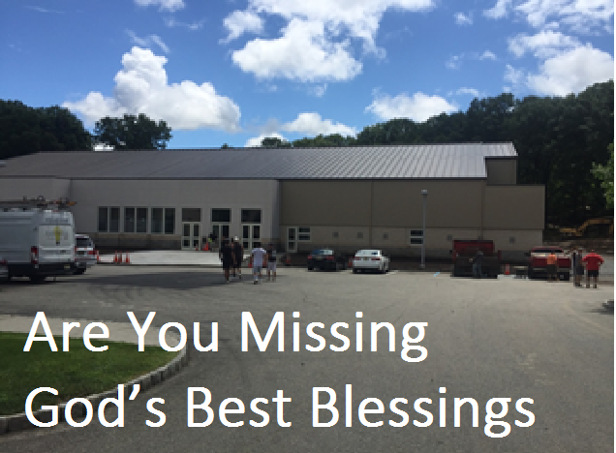
Moses
- Considered one of the biblical hero
- Led the Israelites out of Egypt
- Withstood their constant complains for 40 years!
- Was a great leader and kept them walking in God’s ways
- Performed great miracles (Parting of the Red Sea)
Moses An Opportunity
Almost Lost:
出埃及記(Exodus) 4: 10-14
4:10 And Moses said unto the Lord, O my Lord, I am not eloquent, neither heretofore, nor since thou hast spoken unto thy servant: but I am slow of speech, and of a slow tongue. | 4:10 摩西對耶和華說、主阿、我素日不是能言的人、就是從你對僕人說話以後、也是這樣、我本是拙口笨舌的。
4:11 And the Lord said unto him, Who hath made man's mouth? or who maketh the dumb, or deaf, or the seeing, or the blind? have not I the Lord? | 4:11 耶和華對他說、誰造人的口呢、誰使人口啞、耳聾、目明、眼瞎呢、豈不是我耶和華麼．
4:12 Now therefore go, and I will be with thy mouth, and teach thee what thou shalt say. | 4:12 現在去罷、我必賜你口才、指教你所當說的話。
4:13 And he said, O my Lord, send, I pray thee, by the hand of him whom thou wilt send. | 4:13 摩西說、主阿、你願意打發誰、就打發誰去罷。
4:14 14 And the anger of the Lord was kindled against Moses, and he said, Is not Aaron the Levite thy brother? I know that he can speak well. And also, behold, he cometh forth to meet thee: and when he seeth thee, he will be glad in his heart. | 4:14 耶和華向摩西發怒說、不是有你的哥哥利未人亞倫麼、我知道他是能言的、現在他出來迎接你、他一見你心裡就歡喜。
Moses almost lost
his blessing from God
- God called Moses to do something great, but Moses hesitated v10
- Moses felt he did not have the talent to do the work 4:1
4:1 And Moses answered and said, But, behold, they will not believe me, nor hearken unto my voice: for they will say, The LORD hath not appeared unto thee. | 4:1 摩西回答說、他們必不信我、也不聽我的話、必說、耶和華並沒有向你顯現。
- Moses was fearful of what man will think, 3:11
3:11 And Moses said unto God, Who am I, that I should go unto Pharaoh, and that I should bring forth the children of Israel out of Egypt? | 3:11 摩西對 神說、我是甚麼人、竟能去見法老、將以色列人從埃及領出來呢。
- Moses wanted God to send someone else and God was angry with Moses 4:13-14
CEM NYC’s Journey and Lessons of Faith
- 1995-2003
  - We were limited in 253 Centre St
  - We wanted to buy a bigger building, expand our ministers and to reach our parents (start chinese congregation)
  - But we did not have the faith, like Moses we kept of saying no to God
    - We backed out from bidding for 2 buildings
- 2003
  - Another opportunity came up (248 Grand St.)
  - Another test of faith, this time we took the big step of faith
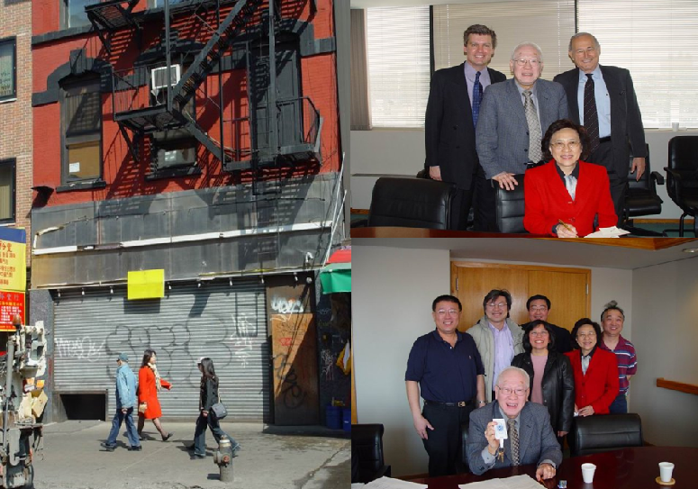
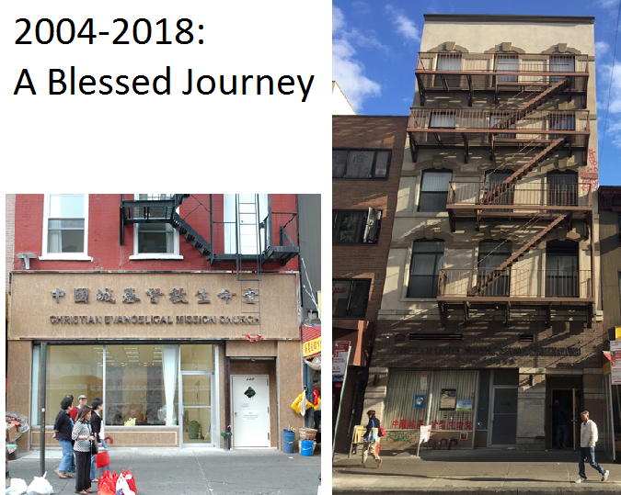
God’s Visible Blessing :
Towaco’s Recreational Building

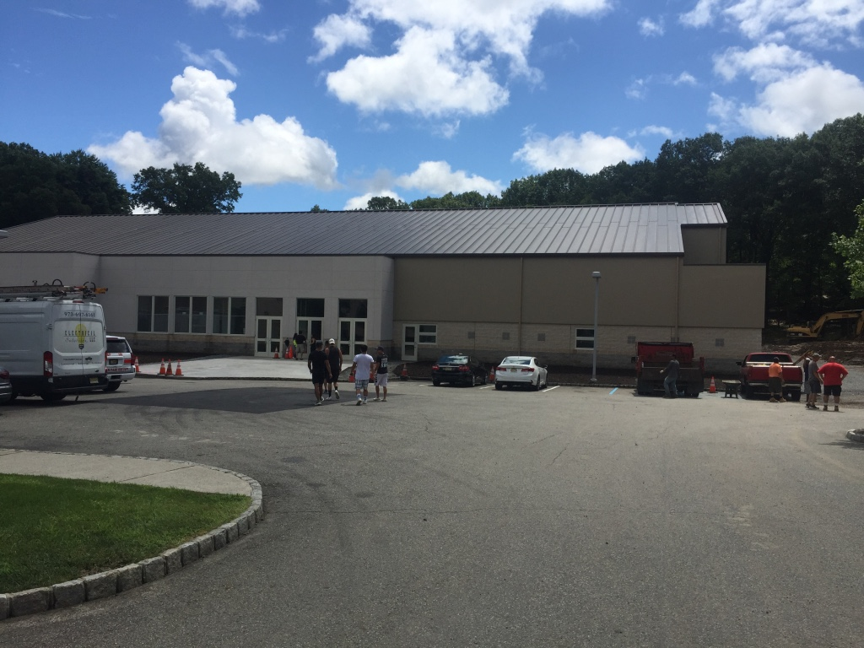
God’s Visible Blessing :
Towaco’s Recreational Building

What limits blessings
in the Church Lessons we learned
- Use worldly wisdom to accomplish spiritual work
  - God’s way is not man’s ways
- Succumb to fear rather than lend on our Faith
  - We doubt God can do great things for us
- Horde our time and money
  - If you are cheap with the Lord, the Lord will be cheap to you
The Same God
- The God that help Moses part the Red Sea and freed the Israelites from Egypt
- The same God that helped NYC buy 248 Grand St in 2004
- The same God that help built the Towaco Recreation Center
- The same God that will help Highland Park Church buy your own church.
申命記 (Deuteronomy) 31:6
31:6 Be strong and of a good courage, fear not, nor be afraid of them: for the Lord thy God, he it is that doth go with thee; he will not fail thee, nor forsake thee. | 31:6 你們當剛強壯膽、不要害怕、也不要畏懼他們、因為耶和華你的 神和你同去、他必不撇下你、也不丟棄你。
BACKG
#416 耶穌是我親愛牧人
Savior, Like a Shepherd Lead Us
===== 1/3 =====
耶穌是我親愛牧人,
Savior, like a shepherd lead us,
親手引領我前程,
Much we need thy tender care;
領我到祢歡樂草場,
In thy pleasant pastures feed us,
領我靠近你身旁。
For our use thy folds prepare.
慈愛救主，慈愛救主，
Blessed Jesus, blessed Jesus!
領我靠近你身旁；
Thou hast bought us, thine we are.
慈愛救主，慈愛救主
Blessed Jesus, blessed Jesus!
領我靠近你身旁。
Thou hast bought us, thine we are.
===== 2/3 =====
耶穌是我最好朋友，
We are thine, thou dost befriend us,
導我天路慰我愁，
Be the guardian of our way;
我縱迷路祂來尋我，
Keep thy flock, from sin defend us,
引導羊群免走錯。
Seek us when we go astray.
慈愛救主，慈愛救主，
Blessed Jesus, blessed Jesus!
願祢常聽我祈求；
Hear Thy children when they pray.
慈愛救主，慈愛救主，
Blessed Jesus, blessed Jesus!
願祢常聽我祈求。
Hear Thy children when they pray.
===== 3/3 =====
讓我趁早討祢歡喜，
Early let us seek thy favor,
樂意遵照祢旨意，
Early let us do thy will;
願主恩愛滿我心中，
Blessed Lord and only Savior,
我願獻身歸主用。
With thy love our bosoms fill.
慈愛救主，慈愛救主，
Blessed Jesus, blessed Jesus!
愛我們直到永久；
Thou hast loved us, love us still.
慈愛救主，慈愛救主，
Blessed Jesus, blessed Jesus!
愛我們直到永久 。
Thou hast loved us, love us still.
BACK
#256 三一頌
Doxology
===== 1/1 =====
讃美真神萬福之根；
Praise God from whom all blessings flow
世上萬民讃美主恩；
Praise Him all creatures here below
天使天軍讃美主名；
Praise Him above ye heav’nly host
讃美聖父, 聖子, 聖靈
Praise Father Son and Holy Ghost
阿門。
Amen
BACK

