高原地基督教生命堂
主日聯合崇拜
Christian Evangelical Mission Church
in Highland Park
二零一八年八月十九日下午一時半
Aug. 19, 2018, 1:30 PM
司會  Chairman: | 謝 徐 穎姊妹  Mrs. Ying Shieh
講員  Speaker: | 黃 宋 來牧師  Rev. Andrew Wong
翻譯  Translator: | 丁薛芬妮姊妹  Mrs. Fanny Tan
司琴  Pianist: | 李 澤 岳弟兄  Mr. Morgen Li
司琴  Pianist: | 王馮韺韺姊妹  Mrs. Ying Ying Wang
司獻  Usher: | 凌 偉 歡弟兄  Mr. Michael Ling
司獻  Usher: | 薛 祝 全弟兄  Mr. Chuh-Chuen Sieh
清潔  Clean Up: | 李 澤 岳弟兄  Mr. Morgen Li
清潔  Clean Up: | 劉 秀 芝姊妹  Ms. Ella Liu

1 | 序 樂  Prelude |  |  |  |  |  | 司琴  Pianist
2 | 宣 召  Call to  Worship | 詩篇Psalm  95:6-7. |  |  |  |  |  |  |  |  |  |  |  |  | 司會  Chairman
3 | 頌讚詩  Hymn of  Praise |  | #245 |  |  |  |  |  |  |  |  | 眾立  Cong. Stand
4 | 祈 禱  Prayer |  |  |  |  |  |  | 司會  Chairman
5 | 讀 經  Scripture  Reading |  | 詩篇(Psalm)  147:11-20 |  |  |  |  |  |  |  |  |  |  | 司會  Chairman
6 | 唱 詩  Hymn |  |  |  | #347 |  |  |  |  | 眾立  Cong. Stand
7 | 報 告  Announcement |  |  |  |  |  |  |  |  |  |  |  |  | 司會  Chairman
8 | 獻 唱  Anthem |  |  | #358 |  |  |  |  |  |  |  |  | 成人詩班  Adult Choir
9 | 證 道  Sermon |  |  |  |  | 黃宋來牧師  Rev. Wong
 | 喜樂的人生(Hppy Life)
 | 腓立比書 (Philippians) 4: 4-7
10 | 回應詩  Response |  |  |  |  | #457 |  |  |  | 眾立  Cong. Stand
11 | 奉 獻  Offering |  |  |  |  |  |  |  |  |  |  |  |  |  |  | 司獻  Usher
12 | 禱 告  Prayer |  |  |  |  | 眾立  Cong. Stand
13 | 三一頌  Doxology |  |  |  |  |  |  | 眾立  Cong. Stand
 | 祝 福  Benediction |  |  |  |  |  |  |  |  |  |  | 黃宋來牧師  Rev. Wong
15 | 阿們頌  Threefold Amen |  |  |  |  |  |  |  |  |  | 眾立  Cong. Stand
16 | 殿 樂  Postlude |  |  |  |  |  |  |  |  |  |  |  |  | 司琴  Pianist
BACK
000主在祂的聖殿中
The Lord is in His holy temple
===== 1/1 =====
上主今在祂的聖会中,
The Lord is in His holy temple
上主今在祂的聖会中,
The Lord is in His holy temple
萬國的人當肅靜,
Let all the earth keep silence,
萬國的人在主前當肅靜,
Let all the earth keep silence,
before Him,
當肅靜,在主前,應當肅靜。
Keep silence, keep silence,
before Him.
阿門。
Amen.
BACK
诗篇 (Psalm) 95:6, 7
95:6 Come, let us bow down in worship, let us kneel before the Lord our Maker; | 95:6 來啊,我們要屈身敬拜,在造我們的耶和華面前跪下 。
95:7 for he is our God and we are the people of his pasture, the flock under his care. | 95:7 因為祂是我們的神；我們是祂草場的羊,是祂手下的民。惟願你們今天聽祂的話 ：
BACKA
#245 聖徒齊來歌唱
Come, Christians, Join to Sing
===== 1/3 =====
聖徒齊來歌唱:哈利路亞!阿門!
Come, Christians, join to sing Alleluia! Amen!
讚美基督我王;哈利路亞!阿門!
Loud praise to Christ our King; Alleluia! Amen!
大家一心頌揚,在寶座前歡唱；
Let all, with heart and voice, Before His throne rejoice;
主必喜悅欣賞:哈利路亞!阿門!
Praise is His gracious choice: Alleluia! Amen!
===== 2/3 =====
齊來向主仰望:哈利路亞!阿門!
Come, lift your hearts on high, Alleluia! Amen!
頌讚聲滿天上;哈利路亞!阿門!
Let praises fill the sky; Alleluia! Amen!
祂是牧者良友,降卑代贖罪尤；
He is our guide and friend; To us He’ll condescend;
祂的慈愛永久:哈利路亞!阿門！
His love shall never end. Alleluia! Amen!
===== 3/3 =====
再來讚美基督:哈利路亞!阿門！
Praise yet our Christ again, Alleluia! Amen!
生命喜樂滿足;哈利路亞!阿門！
Life shall not end the strain; Alleluia! Amen!
在天福樂美境,主前崇拜奉敬；
On heaven’s blissful shore, His goodness we’ll adore,
歌唱永遠不停:哈利路亞!阿門！
Singing forevermore, “Alleluia! Amen!”
BACKB
詩篇 147:11-20
(Psalms Chapter 147:11-20)
147:11 the Lord delights in those who fear him, who put their hope in his unfailing love. | 147:11 耶和華喜愛敬畏他、和盼望他慈愛的人。
147:12 Extol the Lord , O Jerusalem; praise your God, O Zion, | 147:12 耶路撒冷阿、你要頌讚耶和華．錫安哪、你要讚美你的 神。
147:13 for he strengthens the bars of your gates and blesses your people within you. | 147:13 因為他堅固了你的門閂、賜福給你中間的兒女。
147:14 He grants peace to your borders and satisfies you with the finest of wheat. | 147:14 他使你境內平安．用上好的麥子使你滿足。
147:15 He sends his command to the earth; his word runs swiftly. | 147:15 他發命在地．他的話頒行最快。
147:16 He spreads the snow like wool and scatters the frost like ashes. | 147:16 他降雪如羊毛、撒霜如爐灰。
147:17 He hurls down his hail like pebbles. Who can withstand his icy blast? | 147:17 他擲下冰雹如碎渣．他發出寒冷、誰能當得起呢。
147:18 He sends his word and melts them; he stirs up his breezes, and the waters flow. | 147:18 他一出令、這些就都消化．他使風颳起、水便流動。
147:19 He has revealed his word to Jacob, his laws and decrees to Israel. | 147:19 他將他的道指示雅各、將他的律例典章指示以色列。
147:20 He has done this for no other nation; they do not know his laws. Praise the Lord . | 147:20 別國他都沒有這樣待過．至於他的典章、他們向來沒有知道。你們要讚美耶和華。
BACKC
#347 求主指示祢的道路
Teach me Your way, O Lord
==== 1/4 ====
主啊，求祢指示，祢的道路！
Teach me Your way, O Lord, teach me Your way!
指示我，帶領我，走祢道路！
Your guiding grace afford, teach me Your way!
使我行在正路,憑信仰望我主，
Help me to walk aright, more by faith, less by sight;
恩光引導指示祢的道路！
lead me with heavenly light, teach me Your way!
==== 2/4 ====
當我憂愁滿懷，喜樂毫無，
When I am sad at heart, teach me Your way!
求主指示我走祢的道路！
When earthly joys depart, teach me Your way!
當我寂寞困苦,不知未來前途，
In hours of loneliness, in times of dire distress,
求主向我指示祢的道路！
in failure or success, teach me Your way!
==== 3/4 ====
黑雲滿佈天空，心裏驚恐，
When doubts and fears arise, teach me Your way!
恩主，求祢指示，祢的道路！
When storm clouds fill the skies, teach me Your way!
不論風雨陰晴,道路是突或平，
Shine through the wind and rain, Through sorrow, grief and pain;
求主指示我走祢的道路！
make now my pathway plain, teach me Your way!
==== 4/4 ====
在世生命結束，天家見主，
Long as my life shall last, teach me Your way!
求主一路指引，祢的道路！
Where’er my lot be cast, teach me Your way!
跑完世上路程,冠冕為我永存。
Until the race is run, until the journey’s done,
仍求主指示我祢的道路！
until the crown is won, teach me Your way!
BACKD
報 告 事 項
1. 聚會前請將手機關機或是轉為振動，以避免影響聚會進行。
2. 今日崇拜後有茶點，歡迎大家留步同享美好團契.
3. 明晚八時於李帶嬌阿姨府上舉行查經聚會, 歡迎弟兄姊妹邀約親友踴躍參加.
4. 本周三晚八時於楊孫錦雲姊妹府上舉行查經禱告會，歡迎弟兄姊妹邀約親友踴躍參加 (弟兄姊妹若有代禱事項請聯絡黃牧師)。
5. 下週崇拜後有聚餐.弟兄姊妹若方便請攜帶一菜分享
6. 上主日中英文聯合崇拜奉獻:$ 768.67.
BACK
Announcements
1. Before the Service begins, please turn your cell phones to vibrate/ silent or off to avoid disturbing the proceedings.
2. We welcome everyone to stay for the refreshments after service.
3. Tomorrow night at 8:00PM, there will have a Bible Study at Mrs. Tai K Lee’s house.
4. On Wednesday night at 8:00 PM, there will be a Bible Study and prayer at Mrs. Grace Yu’s house.
5. Next Sunday after service, we will have lunch potluck, please bring
a dish to share.
6. Last week’s offering: $ 768.67.
BACKD
#358 有平安在我心
Constantly Abiding
==== 1/3 ====
有平安在我心，非世界所能賜,
There’s a peace in my heart that the world never gave,
這平安無人能奪去；
A peace it cannot take away;
雖試煉與艱難，如雲四面環繞,
Though the trials of life may surround like a cloud,
我心裡永遠有這平安。
I’ve a peace that has come here to stay!
永遠在我心裡，耶穌屬我；
Constantly abiding, Jesus is mine;
永遠在我心裡，無限快樂；
Constantly abiding, rapture divine;
主總不把我撇棄，慈聲對我說:
He never leaves me lonely, whispers, O so kind:
我總不離開你。耶穌屬我。
“I will never leave thee,” Jesus is mine.
==== 2/3 ====
當這甜美平安，充滿在我心中,
All the world seemed to sing of a Savior and King,
普世似向我主歌頌；
When peace sweetly came to my heart;
黑暗頓成光明，愁苦全失蹤影,
Troubles all fled away and my night turned to day,
萬福主耶穌何等光榮。
Blessed Jesus, how glorious Thou art!
永遠在我心裡，耶穌屬我；
Constantly abiding, Jesus is mine;
永遠在我心裡，無限快樂；
Constantly abiding, rapture divine;
主總不把我撇棄，慈聲對我說:
He never leaves me lonely, whispers, O so kind:
我總不離開你。耶穌屬我。
“I will never leave thee,” Jesus is mine.
==== 3/3 ====
主賜我這珍寶，藏在我心殿中,
This treasure I have in a temple of clay,
在世寄居平安融融；
While here on His footstool I roam;
將來榮耀大日，主必再來接我,
But He’s coming to take me some glorious day,
回到天上榮美父家中。
Over there to my heavenly home!
永遠在我心裡，耶穌屬我；
Constantly abiding, Jesus is mine;
永遠在我心裡，無限快樂；
Constantly abiding, rapture divine;
主總不把我撇棄，慈聲對我說:
He never leaves me lonely, whispers, O so kind:
我總不離開你。耶穌屬我。
“I will never leave thee,” Jesus is mine.
BACKE
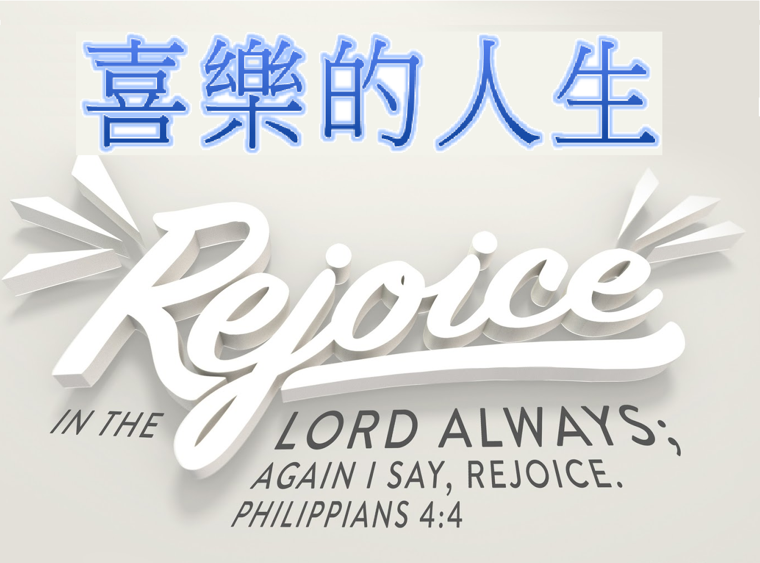
腓立比書(Philippians) 4: 4-7
4:4 Rejoice in the Lord always. I will say it again: Rejoice! | 4:4 你們要靠主常常喜樂．我再說、你們要喜樂。
4:5 Let your gentleness be evident to all. The Lord is near. | 4:5 當叫眾人知道你們謙讓的心。主已經近了。
4:6 Do not be anxious about anything, but in everything, by prayer and petition, with thanksgiving, present your requests to God. | 4:6 應當一無挂慮、只要凡事藉著禱告、祈求、和感謝、將你們所要的告訴 神。
4:7 And the peace of God, which transcends all understanding, will guard your hearts and your minds in Christ Jesus. | 4:7 神所賜出人意外的平安、必在基督耶穌裡、保守你們的心懷意念。
BACKG
#457 我今永遠屬祢
Now I Belong to Jesus
===== 1/3 =====
耶穌我主爱我永不止息，
Jesus, my Lord will love me forever,
無權勢能叫我與主分離，
From Him no pow'r of evil can sever,
祂救贖我捨命於十架，
He gave His life to ransom my soul;
我今永遠屬祂；
Now I belong to Him;
我今屬於主耶穌，
Now I belong to Jesus,
主耶穌屬於我，
Jesus belongs to me,
並非暫時舆祂相連，
Not for the years of time alone,
乃是直到永遠。
But for eternity.
===== 2/3 =====
從前我在罪中迷醉浮沉，
Once I was lost in sin's degradation,
耶穌降世給我帶來救恩，
Jesus came down to bring me salvation,
不再有羞恥憂傷懼怕，
Lifted me up from sorrow and shame,
我今永遠屬祂；
Now I belong to Him;
我今屬於主耶穌，
Now I belong to Jesus,
主耶穌屬於我，
Jesus belongs to me,
並非暫時舆祂相連，
Not for the years of time alone,
乃是直到永遠。
But for eternity.
===== 3/3 =====
我心快樂因我已得拯救，
Joy floods my soul for Jesus has saved me,
前為罪奴今主赐我自由，
Freed me from sin that long had enslaved me
為救贖我祂寶血流下，
His precious blood, He came to redeem,
我今永遠屬祂；
Now I belong to Him;
我今屬於主耶穌，
Now I belong to Jesus,
主耶穌屬於我，
Jesus belongs to me,
並非暫時舆祂相連，
Not for the years of time alone,
乃是直到永遠。
But for eternity.
BACK
#256 三一頌
Doxology
===== 1/1 =====
讃美真神萬福之根；
Praise God from whom all blessings flow
世上萬民讃美主恩；
Praise Him all creatures here below
天使天軍讃美主名；
Praise Him above ye heav’nly host
讃美聖父, 聖子, 聖靈
Praise Father Son and Holy Ghost
阿門。
Amen
BACK

