高原地基督教生命堂
主日聯合崇拜
Christian Evangelical Mission Church
in Highland Park
二零一八年九月廿三日下午一時半
Sep. 23, 2018, 1:30 PM
司會  Chairman: | 謝 徐 穎姊妹  Mrs. Ying Shieh
講員  Speaker: | 黃 健 中弟兄  Mr. Kenny Wong
翻譯  Translator: | 彭 李 蓉姊妹  Mrs. Dolly Peng
司琴  Pianist: | 李 澤 岳弟兄  Mr. Morgen Li
司琴  Pianist: | 王馮韺韺姊妹  Mrs. Ying Ying Wang
司獻  Usher: | 王 培 仁弟兄  Mr. Peiren Wang
司獻  Usher: | 王 強 弟兄  Mr. Charli Wang
清潔  Clean Up: | 黃 明 弟兄  Mr. Ming Huang
清潔  Clean Up: | 黃王正芳姊妹  Mrs. Irene Huang

1 | 序 樂  Prelude |  |  |  |  |  | 司琴  Pianist
2 | 宣 召  Call to  Worship | 詩篇Psalm  95:6-7. |  |  |  |  |  |  |  |  |  |  |  |  | 司會  Chairman
3 | 頌讚詩  Hymn of  Praise |  | #5 |  |  |  |  |  |  |  |  | 眾立  Cong. Stand
4 | 祈 禱  Prayer |  |  |  |  |  |  | 司會  Chairman
5 | 讀 經  Scripture  Reading |  | 詩篇1篇  (舊659頁)  Psalm 1 |  |  |  |  |  |  |  |  |  |  | 司會  Chairman
6 | 唱 詩  Hymn |  |  |  | #347 |  |  |  |  | 眾立  Cong. Stand
7 | 報 告  Announcement |  |  |  |  |  |  |  |  |  |  |  |  | 司會  Chairman
8 | 獻 唱  Anthem |  |  | #442 |  |  |  |  |  |  |  |  | 成人詩班  Adult Choir
9 | 證 道  Sermon |  |  |  |  | 黃健中弟兄  Mr.Wong
超越偉人
(Victory over Giants)
 | 使徒行傳(Acts)20: 24節…
10 | 回應詩  Response |  |  |  |  | #336 |  |  |  | 眾立  Cong. Stand
11 | 奉 獻  Offering |  |  |  |  |  |  |  |  |  |  |  |  |  |  | 司獻  Usher
12 | 禱 告  Prayer |  |  |  |  | 眾立  Cong. Stand
13 | 三一頌  Doxology |  |  |  |  |  |  | 眾立  Cong. Stand
14 | 祝 福  Benediction |  |  |  |  |  |  |  |  |  |  | 黃健中弟兄  Mr. Wong
15 | 阿們頌  Threefold Amen |  |  |  |  |  |  |  |  |  | 眾立  Cong. Stand
16 | 殿 樂  Postlude |  |  |  |  |  |  |  |  |  |  |  |  | 司琴  Pianist
本週金句This week’s Bible verse
馬太福音 (Matthew) 11:28:
凡勞苦擔重擔的人, 可以到我這裡來, 我就使你們得安息。
Come to me. All you who weary and burdened, and I will give You rest.
BACK
000主在祂的聖殿中
The Lord is in His holy temple
===== 1/1 =====
上主今在祂的聖会中,
The Lord is in His holy temple
上主今在祂的聖会中,
The Lord is in His holy temple
萬國的人當肅靜,
Let all the earth keep silence,
萬國的人在主前當肅靜,
Let all the earth keep silence,
before Him,
當肅靜,在主前,應當肅靜。
Keep silence, keep silence,
before Him.
阿門。
Amen.
BACK
诗篇 (Psalm) 95:6, 7
95:6 Come, let us bow down in worship, let us kneel before the Lord our Maker; | 95:6 來啊,我們要屈身敬拜,在造我們的耶和華面前跪下 。
95:7 for he is our God and we are the people of his pasture, the flock under his care. | 95:7 因為祂是我們的神；我們是祂草場的羊,是祂手下的民。惟願你們今天聽祂的話 ：
BACKA
#5 這是天父世界
This Is My Father’s World
== 1/3 ==
這是天父世界，
This is my Father’s world,
孩童側耳要聽，
and to my listening ears
宇宙唱歌，四圍響應，
All nature sings, and round me rings
星辰作樂同聲。
the music of the spheres.
這是天父世界，
This is my Father’s world:
我心滿有安寧，
I rest me in the thought
樹木花草，蒼天碧海，
Of rocks and trees, of skies and seas;
述說天父全能。
His hand the wonders wrought.
== 2/3 ==
這是天父世界，
This is my Father’s world,
小鳥展翅飛鳴，
the birds their carols raise,
清晨明亮，好花美麗，
The morning light, the lily white,
證明天理精深。
declare their Maker’s praise.
這是天父世界，
This is my Father’s world:
祂愛普及萬千，
He shines in all that’s fair;
風吹之草將祂表現，
In the rustling grass I hear Him pass;
天父充滿世間。
He speaks to me everywhere.
== 3/3 ==
這是天父世界，
This is my Father’s world.
求主叫我不忘，
O let me ne’er forget
罪惡雖然好像得勝，
That though the wrong seems oft so strong,
天父卻仍掌管。
God is the ruler yet.
這是天父世界，
This is my Father’s world:
我心不必憂傷，
the battle is not done:
父神是王，天地同唱，
Jesus Who died shall be satisfied,
歌聲充滿萬方。
And earth and Heav’n be one.
BACKB
詩篇 1 篇
(Psalms Chapter 1)
1:1 Blessed is the man who does not walk in the counsel of the wicked or stand in the way of sinners or sit in the seat of mockers. | 1:1 不從惡人的計謀、不站罪人的道路、不坐褻慢人的座位、
1:2 But his delight is in the law of the Lord, and on his law he meditates day and night. | 1:2 惟喜愛耶和華的律法、晝夜思想、這人便為有福。
1:3 He is like a tree planted by streams of water, which yields its fruit in season and whose leaf does not wither. Whatever he does prospers. | 1:3 他要像一棵樹栽在溪水旁、按時候結果子、葉子也不枯乾．凡他所作的、盡都順利。
1:4 Not so the wicked! They are like chaff that the wind blows away. | 1:4 惡人並不是這樣、乃像糠秕被風吹散。
1:5 Therefore the wicked will not stand in the judgment, nor sinners in the assembly of the righteous. | 1:5 因此當審判的時候、惡人必站立不住．罪人在義人的會中、也是如此。
1:6 For the Lord watches over the way of the righteous, but the way of the wicked will perish. | 1:6 因為耶和華知道義人的道路．惡人的道路、卻必滅亡。。
BACKC
#347 求主指示祢的道路
Teach me Your way, O Lord
==== 1/4 ====
主啊，求祢指示，祢的道路！
Teach me Your way, O Lord, teach me Your way!
指示我，帶領我，走祢道路！
Your guiding grace afford, teach me Your way!
使我行在正路，憑信仰望我主，
Help me to walk aright, more by faith, less by sight;
恩光引導指示祢的道路！
lead me with heavenly light, teach me Your way!
==== 2/4 ====
當我憂愁滿懷，喜樂毫無，
When I am sad at heart, teach me Your way!
求主指示我走祢的道路！
When earthly joys depart, teach me Your way!
當我寂寞困苦，不知未來前途，
In hours of loneliness, in times of dire distress,
求主向我指示祢的道路！
in failure or success, teach me Your way!
==== 3/4 ====
黑雲滿佈天空，心裏驚恐，
When doubts and fears arise, teach me Your way!
恩主，求祢指示，祢的道路！
When storm clouds fill the skies, teach me Your way!
不論風雨陰晴，道路是突或平，
Shine through the wind and rain, Through sorrow, grief and pain;
求主指示我走祢的道路！
make now my pathway plain, teach me Your way!
==== 4/4 ====
在世生命結束，天家見主，
Long as my life shall last, teach me Your way!
求主一路指引，祢的道路！
Where’er my lot be cast, teach me Your way!
跑完世上路程，冠冕為我永存。
Until the race is run, until the journey’s done,
仍求主指示我祢的道路！
until the crown is won, teach me Your way!
BACKD
報 告 事 項
1. 聚會前請將手機關機或是轉為振動，以避免影響聚會進行。
2. 今日崇拜後有茶點，歡迎大家留步同享美好團契.
3. 週三晚查經禱告會暫停，10/24/18恢復聚會.
4. 下週崇拜後有聚餐,弟兄姊妹若方便請攜帶一菜分享.
5. 上主日中英文聯合崇拜奉獻: $1379.00. 週一餐館查經聚會奉獻: $405.00
BACK
Announcements
1. Before the Service begins, please turn your cell phones to vibrate/silent or off to avoid disturbing the proceedings.
2. We welcome everyone to stay for refreshments after service.
3. Wednesday night Bible Study and prayer meeting will be cancel until Oct 24, 2018 resume.
4. Next Sunday after service, we will have lunch potluck, please bring a dish to share.
5. Last week’s offering: $1379.00. Monday Bible Study offering: $ 405.00.
BACKD
#442 愛使我們合一
The Bond of Love
==== 1/2 ====
主的愛使我們合一，
We are one in the bond of love
主的愛使我們合一；
We are one in the bond of love
主的聖靈充滿在我們的心裡，
We have joined our spirit with the Spirit of God
主的愛使我們合一
We are one in the bond of love.
==== 2/2 ====
讓我們同聲歡唱，
Let us sing now, ev'ry one,
主的愛彼此分享；
Let us feel His love begun;
讓我們攜手同心向世人證明，
Let us join our hand that the world will know
主的愛使我們合一。
We are one in the bond of love.
BACKE
超越偉人
(Victory over Giants)
使徒行傳 (Acts) 20: 24
But none of these things move me, neither count I my life dear unto myself, so that I might finish my course with joy, and the ministry which I have received from the Lord Jesus, to testify to the Gospel of the grace of God. |  |  |  | 我卻不以性命為念、也不看為寶貴、只要行完我的路程、成就我從主耶穌所領受的職事、證明 神恩惠的福音。
- The Giants in the Bible
- Before the flood
創世紀 (Genesis) 6:4
There were giants (nephilim) in the earth in those days; and also after that, when the sons of God came in unto the daughters of men, and they bare children to them, the same became mighty men which were of old, men of renown. |  |  |  |  | 那時候有偉人在地上、後來 神的兒子們、和人的女子們交合生子、那就是上古英武有名的人。
- During Abram and Lot times
創世紀 (Genesis) 14:5-7
⁵And in the fourteenth year came Chedorlaomer, and the kings that were with him, and smote the Rephaims in Ashteroth Karnaim, and the Zuzims in Ham, and the Emins in Shaveh Kiriathaim,  ⁶And the Horites in their mount Seir, unto Elparan, which is by the wilderness.  ⁷And they returned, and came to Enmishpat, which is Kadesh, and smote all the country of the Amalekites, and also the Amorites, that dwelt in Hazezontamar. |  |  | ⁵十四年基大老瑪和同盟的王、都來在亞特律加寧、殺敗了利乏音人、在哈麥殺敗了蘇西人、  ⁶在沙微基列亭殺敗了以米人、在何利人的西珥山殺敗了何利人、一直殺到靠近曠野的伊勒巴蘭。  ⁷他們回到安密巴、就是加低斯、殺敗了亞瑪力全地的人、以及住在哈洗遜他瑪的亞摩利人。
- During Joshua (Caleb) time
民數記 (Numbers) 13:33
And there we saw the giants, the sons of Anak, which come of the giants: and we were in our own sight as grasshoppers, and so we were in their sight. |  | 我們在那裡看見亞衲族人、就是偉人、他們是偉人的後裔、據我們看自己就如蚱蜢一樣、據他們看我們也是如此。
- During King David’s time Goliath, the Philistine (1Sam 17)
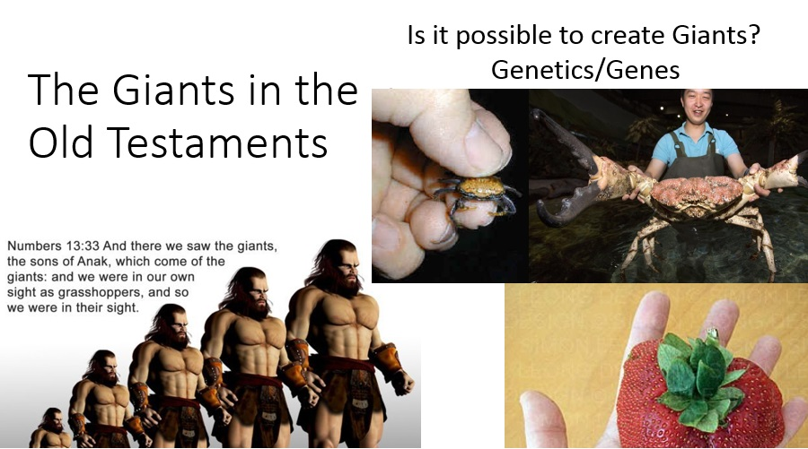
- The Giant’s size is dependent on your Faith
- The exact size of the son’s of Anak is not known

- That is because it is not important

- Our perspective creates the Giant’s size

if we walk by sight and not by faith

- But, if we have faith the giants become small relative to the “size” of God

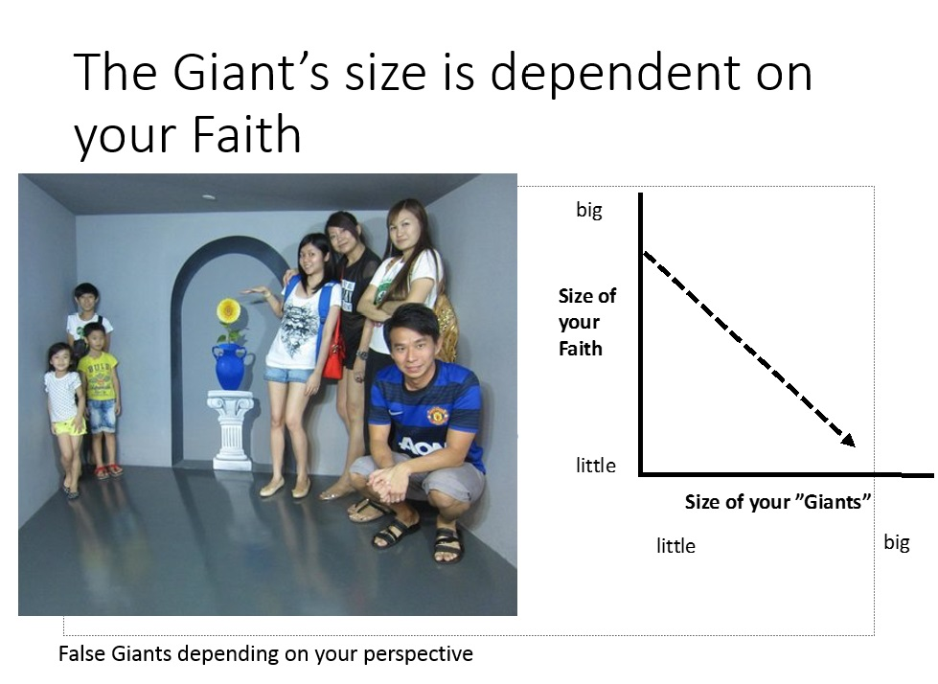
- Why do Giants exist in our lives?
- To remind us that we are small relative to “our giants”

- To remind us that God is bigger than “our giants”

Without the giants in our lives we would not know how big God is.

Acts 20:24

使徒行傳 (Acts) 20:24
But none of these things move me, neither count I my life dear unto myself, so that I might finish my course with joy, and the ministry which I have received from the Lord Jesus, to testify to the Gospel of the grace of God. |  |  |  | 我卻不以性命為念、也不看為寶貴、只要行完我的路程、成就我從主耶穌所領受的職事、證明 神恩惠的福音。
- The Apostle Paul had a giant in his life

- How did Paul dealt with this particular giant? 4 points

- Paul had a Disciplined Mind
- But none of these things move me
- Paul was heading to Jerusalem and then unto Rome
- Acts 20:22
使徒行傳 (Acts) 20:22
And now, behold, I go bound in the spirit unto Jerusalem, not knowing the things that shall befall me there: | 現在我往耶路撒冷去、心甚迫切、〔原文作心被捆綁〕不知道在那裡要遇見甚麼事．
- He will be facing his critics and enemies
- He didn’t know what will happen to him
- But Paul had a disciplined mind and his situation did not perturb him
- Anxieties, worries and fear accompany our daily life (attack of our mind)
- Can we say what Apostle Paul said?

- Paul had a Prioritized Life
- neither count I my life dear unto myself
- Paul took inventory of his life and what was most important to him was serving God
- He was not living a life for himself, but for God. That was Paul’s priority
- God sent sent him to Jerusalem to do work, God’s work
- Paul knew and practice the principle in Matt 6:33

馬太福音 (Matthew) 6:33
But seek ye first the kingdom of God, and his righteousness; and all these things shall be added unto you. | 你們要先求他的國、和他的義這些東西都要加給你們了。
- Paul had a Defined Purpose (Plan)
- so that I might finish my course with joy
- Paul had clarity in what he needed to do in his life.
- And if he run and complete the race, he will be joyful
- Many Christians don’t run the race
  - so they don’t have joy (from God)
- Paul not only wanted to run the race, he want to finish it, to receive the prize
- Many Christians quit running the race.
  - They get disqualified and lose their joy.

- Paul had a Divine Purpose
- and the ministry, which I have received of the Lord Jesus, to testify the gospel of the grace of God.
- The race (purpose) was given to Paul by Jesus Christ
- Received by Paul, maintained by the Holy Spirit
- for what purpose is this race? For the sake of the gospel
- This Divine purpose will have enemies. The goal is to
  - trip you up (stumble)
  - distract you (wrong focus)
  - make you quit the race (disqualified)

- Do not lose sight of your victory
哥林多後書 (2 Corinthians)
4:7-10
- ⁷But we have this treasure in earthen vessels, that the excellency of the power may be of God, and not of us.  - ⁸We are troubled on every side, yet not distressed; we are perplexed, but not in despair;  - ⁹Persecuted, but not forsaken; cast down, but not destroyed;  - ¹⁰Always bearing about in the body the dying of the Lord Jesus, that the life also of Jesus might be made manifest in our body. | - ⁷ 我們有這寶貝放在瓦器裡、要顯明這莫大的能力、是出於 神、不是出於我們。  - ⁸我們四面受敵、卻不被困住．心裡作難、卻不至失望．  - ⁹遭逼迫、卻不被丟棄．打倒了、卻不至死亡．  - ¹⁰身上常帶著耶穌的死、使耶穌的生、也顯明在我們身上。
Christ’s work on the cross not only saved us (in heaven) but works in us (on earth) to show how big God is.

- Some Questions to Think About
- Some Questions to Think About
- What are things that move (trouble) you? Your Giants
  - your worries, fears and anxieties
  - how do you deal with them?
- Is it clear to you what “race” you are running in this life?
- What are your top 3 high priority items in your life?
  - Is God in the top 3?
  - Matt 6:20-21,22: But lay up for yourselves treasures in heaven, where neither moth nor rust doth corrupt, and where thieves do not break through nor steal: For where your treasure is, there will your heart be also.

馬太福音 (Matthew) 6:20-22
²⁰But lay up for yourselves treasures in heaven, where neither moth nor rust doth corrupt, and where thieves do not break through nor steal:  ²¹For where your treasure is, there will your heart be also.  ²²The light of the body is the eye: if therefore thine eye be single, thy whole body shall be full of light. |  |  |  | ²⁰只要積儹財寶在天上、天上沒有蟲子咬、不能鏽壞、也沒有賊挖窟窿來偷．  ²¹因為你的財寶在那裡、你的心也在那裡。  ²²眼睛就是身上的燈．你的眼睛若瞭亮、全身就光明。
- Has God given you a ”race” to run like Paul?
  - have you accepted?
  - have you quit?

BACKG
#336 主啊，容我與檷同行
O Master, Let Me Walk with Thee
==== 1/4 ====
主啊容我與你同行
O Master let me walk with Thee
甘願自卑 服事他人
In lowly paths of service free
求主示我 治事秘訣
Tell me Thy secret help me bear
教我忍耐克服艱辛
The strain of toil the fret of care
==== 2/4 ====
求主助我善用愛心
Help me the slow of heart to move
常以良言 感化鄰人
By some clear winning word of love
隨時隨地 引人離惡
Teach me the wayward feet to stay
歸依救主行走天程
And guide them in the homeward way
==== 3/4 ====
求主教我學你忍耐
Teach me Thy patience
與主相親 與主同在
still with Thee In close dearer company
工作之時 加我信心
In work that keeps faith sweet and strong
使我剛強 將敵戰敗
In trust that triumphs over wrong
==== 4/4 ====
求主助我盼望常存
In hope that sends a shining ray
展望前程 遠大光明
Far down the future’s broad’ning way
無上平安惟主能賜
In peace that only Thou canst give
主啊 容我 與檷同行
With Thee O Master let me live
BACK
#256 三一頌
Doxology
===== 1/1 =====
讃美真神萬福之根；
Praise God from whom all blessings flow
世上萬民讃美主恩；
Praise Him all creatures here below
天使天軍讃美主名；
Praise Him above ye heav’nly host
讃美聖父, 聖子, 聖靈
Praise Father Son and Holy Ghost
阿門。
Amen
BACK

