高原地基督教生命堂
主日聯合崇拜
Christian Evangelical Mission Church
in Highland Park
二零一八年十月七日下午一時半
Oct. 7, 2018, 1:30 PM
司會  Chairman: | 黃 明 弟兄  Mr. Ming Huang
講員  Speaker: | 楊張秀蘭傳道  Ev. Sorina Yang
翻譯  Translator: | 彭 李 蓉姊妹  Mrs. Dolly Peng
司琴  Pianist: | 李 澤 岳弟兄  Mr. Morgen Li
司琴  Pianist: | 王馮韺韺姊妹  Mrs. Ying Y. Wang
司獻  Usher: | 陳 耀 根弟兄  Mr. Yiu Kan Chan
司獻  Usher: | 林 富 明弟兄  Mr. Ming Lim
清潔  Clean Up: | 林 富 明弟兄  Mr. Ming Lim
清潔  Clean Up: | 林黃秋娥姊妹  Mrs. Connie Lim
遞聖餐  Communion: | 王 強 弟兄  Mr. Charlie Wang
遞聖餐  Communion: | 王 培 仁弟兄  Mr. Charli Wang

1 | 序 樂  Prelude |  |  |  |  |  |  |  | 司琴  Pianist
2 | 宣 召  Call to  Worship | 詩篇Psalm  95:6-7. |  |  |  |  |  |  |  |  |  |  |  |  |  |  | 司會  Chairman
3 | 頌讚詩  Hymn of  Praise |  | #417 |  |  |  |  |  |  |  |  |  |  | 眾立  Cong. Stand
4 | 祈 禱  Prayer |  |  |  |  |  |  |  |  | 司會  Chairman
5 | 讀 經  Scripture  Reading |  | 詩篇3篇  (舊659頁)  Psalm 3 |  |  |  |  |  |  |  |  |  |  |  |  | 司會  Chairman
6 | 唱 詩  Hymn |  |  |  | #454 |  |  |  |  |  |  | 眾立  Cong. Stand
7 | 報 告  Announcement |  |  |  |  |  |  |  |  |  |  |  |  |  |  | 司會  Chairman
8 | 獻 唱  Anthem |  |  | #476 |  |  |  |  |  |  |  |  |  |  | 成人詩班  Adult Choir
9 | 證 道 |  |  |  |  | 楊張秀蘭傳道  Ev.Yang
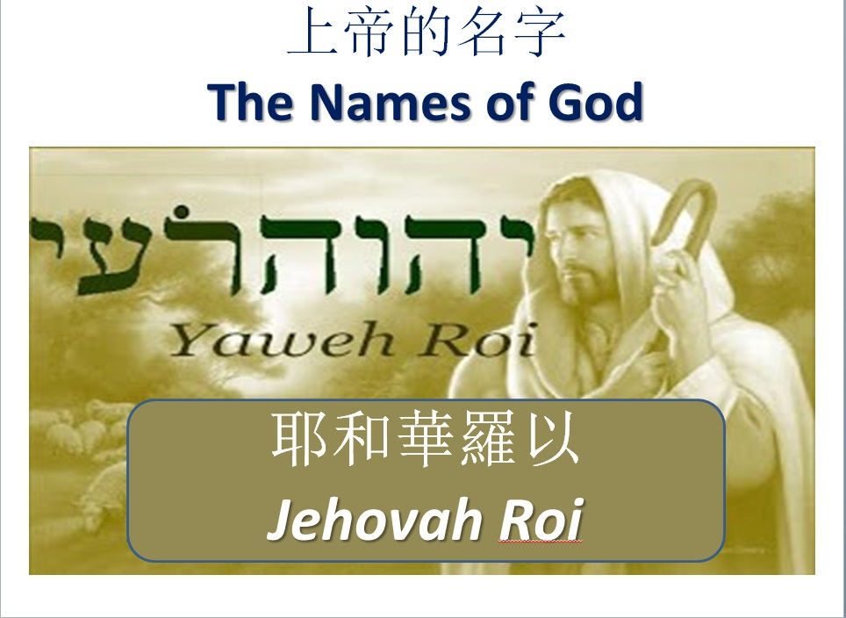
10 | 回應詩  Response |  |  |  |  | #174 |  |  |  |  |  | 眾立  Cong. Stand
11 | 聖 餐  Communion |  |  |  |  |  |  | 楊張秀蘭傳道  Ev. Yang
12 | 奉 獻  Offering |  |  |  |  |  |  |  |  |  |  |  |  |  |  |  |  | 司獻  Usher
13 | 禱 告  Prayer |  |  |  |  | 眾立  Cong. Stand
14 | 三一頌  Doxology |  |  |  |  |  |  |  |  | 眾立  Cong. Stand
15 | 祝 福  Benediction |  |  |  |  |  | 楊張秀蘭傳道  Ev. Yang
16 | 阿們頌  Threefold Amen |  |  |  |  |  |  |  |  |  |  |  | 眾立  Cong. Stand
17 | 殿 樂  Postlude |  |  |  |  |  |  |  |  |  |  |  |  |  |  | 司琴  Pianist
BACK
000主在祂的聖殿中
The Lord is in His holy temple
===== 1/1 =====
上主今在祂的聖会中,
The Lord is in His holy temple
上主今在祂的聖会中,
The Lord is in His holy temple
萬國的人當肅靜,
Let all the earth keep silence,
萬國的人在主前當肅靜,
Let all the earth keep silence,
before Him,
當肅靜,在主前,應當肅靜。
Keep silence, keep silence,
before Him.
阿門。
Amen.
BACK
诗篇 (Psalm) 95:6, 7
95:6 Come, let us bow down in worship, let us kneel before the Lord our Maker; | 95:6 來啊,我們要屈身敬拜,在造我們的耶和華面前跪下 。
95:7 for he is our God and we are the people of his pasture, the flock under his care. | 95:7 因為祂是我們的神；我們是祂草場的羊,是祂手下的民。惟願你們今天聽祂的話 ：
BACKA
#417 祂何等愛你，愛我
O How He Loves You and Me
===== 1/4 =====
主耶穌何等愛你，
O how He loves you and me!
祂也何等的愛我；
O how He loves you and me!
祂將生命完全的給你。
He gave His life; what more could He give?
祂何等愛你，祂何等愛我，
O how He loves you; O how He loves me;
祂何等愛你，愛我。
O how He loves you and me!
===== 2/2 =====
耶穌曾到骷髏地，
Jesus to Calv’ry did go,
爲愛世人捨自己；
His love for mankind to show.
帶給罪人盼望與生命。
What He did there brought hope from despair.
祂何等愛你 祂何等愛我，
O how He loves you; O how He loves me;
祂何等愛你，愛我，
O how He loves you and me!
BACKB
詩篇 3 篇
(Psalms Chapter 3)
3:1 O Lord , how many are my foes! How many rise up against me! | 3:1 〔大衛逃避他兒子押沙龍的時候作的詩。〕耶和華阿、我的敵人何其加增．有許多人起來攻擊我。
3:2 Many are saying of me, "God will not deliver him." Selah | 3:2 有許多人議論我說、他得不著 神的幫助。〔細拉〕
3:3 But you are a shield around me, O Lord ; you bestow glory on me and lift up my head. | 3:3 但你耶和華是我四圍的盾牌．是我的榮耀、又是叫我抬起頭來的。
3:4 To the Lord I cry aloud, and he answers me from his holy hill. Selah | 3:4 我用我的聲音求告耶和華、他就從他的聖山上應允我。〔細拉〕
3:5 I lie down and sleep; I wake again, because the Lord sustains me. | 3:5 我躺下睡覺．我醒著．耶和華都保佑我。
3:6 I will not fear the tens of thousands drawn up against me on every side. | 3:6 雖有成萬的百姓來周圍攻擊我、我也不怕。
3:7 Arise, O Lord ! Deliver me, O my God! Strike all my enemies on the jaw; break the teeth of the wicked. | 3:7 耶和華阿、求你起來．我的 神阿、求你救我．因為你打了我一切仇敵的腮骨、敲碎了惡人的牙齒。
3:8 From the Lord comes deliverance. May your blessing be on your people. Selah | 3:8 救恩屬乎耶和華．願你賜福給你的百姓。〔細拉〕
BACKC
#454 主愛救我
Love Lifted Me
==== 1/3 ====
我曾陷溺罪海中，遠離了安全港，
I was sinking deep in sin, far from the peaceful shore,
被罪惡壓身深重，心中痛苦失望；
Very deeply stained within, sinking to rise no more,
幸蒙萬有大主宰，聽我哭喊之聲，
But the Master of the sea heard my despairing cry,
恩手救我離苦海，免我沉淪。
From the waters lifted me, now safe am I.
主愛救我，主愛救我；
Love lifted me! Love lifted me!
當我灰心絕望，主愛救我。
When nothing else could help, Love lifted me!
主愛救我，主愛救我；
Love lifted me! Love lifted me!
當我灰心絕望，主愛救我。
When nothing else could help, Love lifted me!
==== 2/3 ====
我今願獻身心靈，跟隨救主到底，
All my heart to Him I give, ever to Him I’ll cling,
我願讚美主聖名，在祂懷中安息；
In His blessed presence live, ever His praises sing,
主的愛廣大真誠，我靈歌唱不停，
Love so mighty and so true, merits my soul’s best songs,
願向主忠心事奉，聽祂命令。
Faithful, loving service, too, to Him belongs.
主愛救我，主愛救我；
Love lifted me! Love lifted me!
當我灰心絕望，主愛救我。
When nothing else could help, Love lifted me!
主愛救我，主愛救我；
Love lifted me! Love lifted me!
當我灰心絕望，主愛救我。
When nothing else could help, Love lifted me!
==== 3/3 ====
當你遇危險災害，應當仰望救主，
Souls in danger, look above, Jesus completely saves,
祂有恩典與大愛，必定拯救幫助；
He will lift you by His love, out of the angry waves;
祂是海洋大主宰，風浪聽祂命令，
He’s the Master of the sea, billows His will obey,
祂今願意你悔改，拯救你命。
He your Savior wants to be, be saved today.
主愛救我，主愛救我；
Love lifted me! Love lifted me!
當我灰心絕望，主愛救我。
When nothing else could help, Love lifted me!
主愛救我，主愛救我；
Love lifted me! Love lifted me!
當我灰心絕望，主愛救我。
When nothing else could help, Love lifted me!
BACKD
報 告 事 項
1. 今日為聖餐主日,已信主者請預備心領受主的杯和餅,同思主愛
2. 今日崇拜後有茶點，歡迎大家留步同享美好團契.
3. 本週三晚查經禱告會暫停，10/24/18 恢復聚會.
4. 下週為聖餐主日,已信主者請預備心領受主的杯和餅,同思主愛.
5. 上主日中英文聯合崇拜奉獻:$838.00.
BACK
Announcements
1. We have Holy Communion today. May all believers prepare your
hearts to remember God’s love.
2. Today after the Sunday worship, we will have refreshments in the
Blue room. Please stay to have fellowship with one another.
3. Wednesday night bible study and prayer meeting will be cancel, until
October 24.2018 resume.
4
4. 4. Next week will be Holy Communion Sunday.
5. Last week’s offering: $838.00.
BACKD
#476 我歌頌禰
I Sing of Thee
==== 1/3 ====
我歌頌你 尊貴的主
I sing of thee, oh blessed Christ,
藉你恩典 把我救贖
For thou hast saved me by thy grace.
你救贖我 代價極重
Redeemed by thee at dreadful price,
我與天使 向你歌頌
With angels I would sing thy praise.
我歌頌你 尊貴的救主
I sing of thee, oh blessed Savior,
用我口舌向你謳歌
Thy praise shall now my tongue employ.
我歌頌你 永遠歌頌你
I’ll sing of thee, oh Lord, forever,
因你喜樂已充滿我
For thou hast filled my soul with joy.
==== 2/3 ====
我歌頌你 縱淚滿襟
I’ll sing of thee and smile through tears,
憂傷來臨 仍覺歡欣
When sorrows come to make me sad.
因我回想 救主恩典
For I remember through the years
使我歌唱 快樂無邊
Thy grace, and sing because I’m glad.
我歌頌你 尊貴的救主
I sing of thee, oh blessed Savior,
用我口舌向你謳歌
Thy praise shall now my tongue employ.
我歌頌你 永遠歌頌你
I’ll sing of thee, oh Lord, forever,
因你喜樂已充滿我
For thou hast filled my soul with joy.
====3/3 ====
我歌頌你 直到離世
Of thee I'll sing while life shall last,
不論在家 海洋陸地
At home, abroad, on land or sea.
或經死亡 進入永生
And when thro' death to life I’ve passed,
永永遠遠 我歌頌你
Forevermore, I’ll sing of thee.
我歌頌你 尊貴的救主
I sing of thee, oh blessed Savior,
用我口舌向你謳歌
Thy praise shall now my tongue employ.
我歌頌你 永遠歌頌你
I’ll sing of thee, oh Lord, forever,
因你喜樂已充滿我
For thou hast filled my soul with joy.
BACKE

BACKG
#174 我曾捨命為你
I Gave My Life
==== 1/4 ====
我曾捨命為你，
I gave My life for thee,
我血為你流出，
My precious blood I shed,
救你從死復起，
That thou might ransomed be,
使你由死得贖；
And quick ended from the dead
為你，為你我命曾捨，
I gave, I gave My life for thee,
你捨何事為我？
What hast thou given for Me?
==== 2/4 ====
我曾拋父家庭，
My Father's house of light,
並我容光寶座，
My glory circled throne
淒涼孤身獨行，
I left for earthly night,
在此暗世經過；
For wanderings sad and lone;
為你，為你天家曾捨，
I left, I left it all for thee,
你拋何福為我？
Hast thou left aught for Me?
==== 3/4 ====
我曾受大苦難，
I suffered much for thee,
非人口舌能說，
More than thy tongue can tell,
臨刑身同囚犯，
Of bitterest agony,
救你地獄得脫；
To rescue thee from hell.
為你，為你我身曾捨，
I've borne, I've borne it all for thee,
你捨何事為我？
What hast thou borne for Me?
==== 4/4 ====
我曾將父救恩，
And I have brought to thee,
從我天上攜來，
Down from My home above,
此恩充滿你身，
Salvation full and free,
即我寬容仁愛；
My pardon and My love;
為你，為你大恩曾施，
I bring, I bring rich gifts to thee,
你將何物獻我？
What hast thou brought to Me?
BACK
#256 三一頌
Doxology
===== 1/1 =====
讃美真神萬福之根；
Praise God from whom all blessings flow
世上萬民讃美主恩；
Praise Him all creatures here below
天使天軍讃美主名；
Praise Him above ye heav’nly host
讃美聖父, 聖子, 聖靈
Praise Father Son and Holy Ghost
阿門。
Amen
BACK

